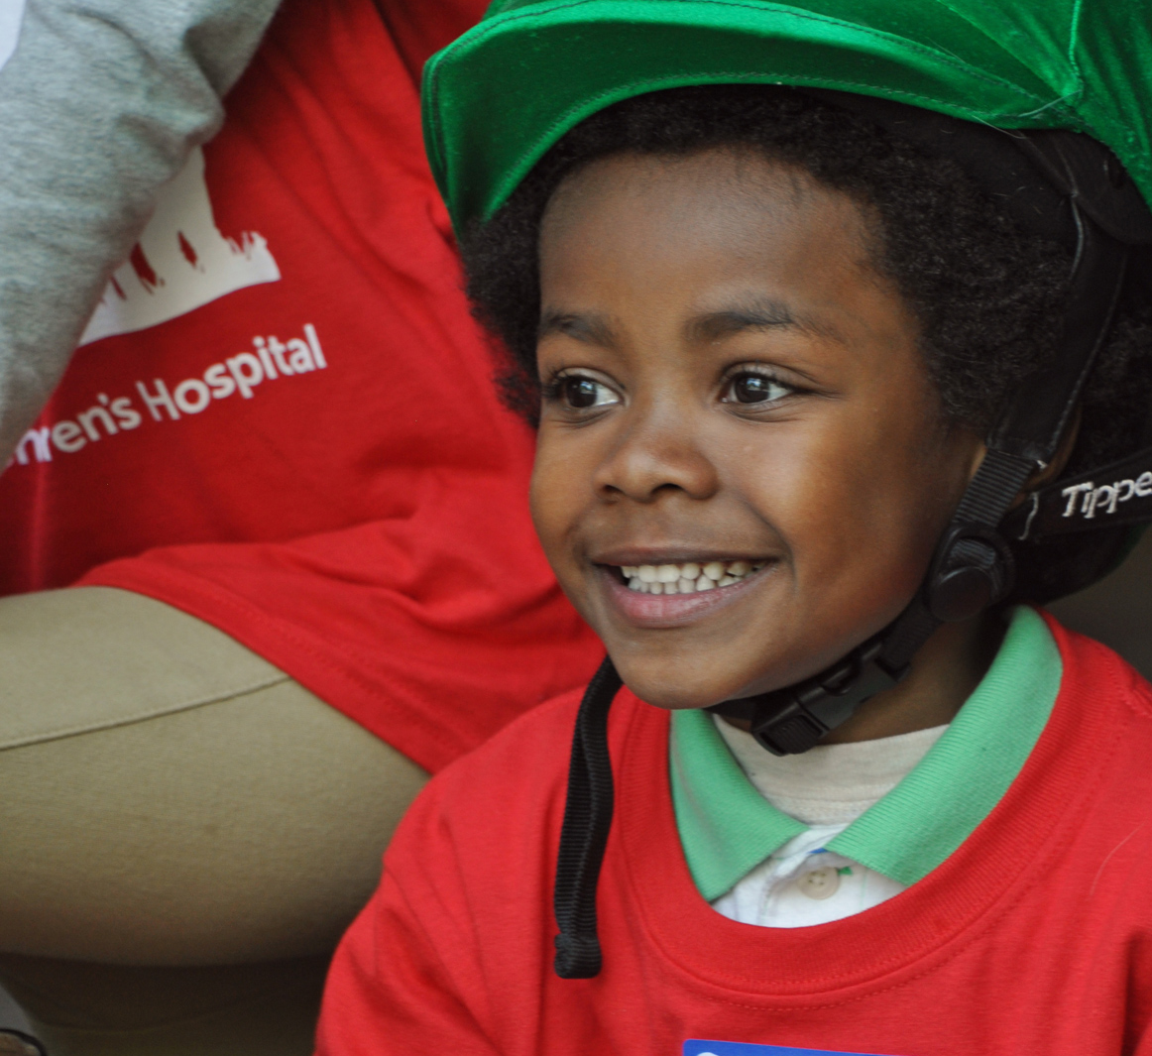
Featured Presentations from the 2017 Cardiac Neurodevelopmental Family Symposium
Directors: Janice Ware, PhD; Caitlin Rollins, MD; Catherin Ullman Shade, PhD
Cardiac Neurodevelopment of Children with Congenital Heart Disease:
Facts, News and Insight for Families
Table of Contents

Cardiac Neurodevelopment: An Overview
by Jane Newburger, MD, MPH 3
Neurodevelopmental Challenges Faced by Children with CHD
by David Bellinger, PhD 5
Congenital Heart Disease in the Family System
by David Demaso, PhD 7
Individual Learning Styles in Congeinital Heart Disease
by Catherine Ullman Shade, PhD, MEd 9
Special Education Law: What You Need to Know
by Daniel Heffernan, JD 11
Thriving with Congenital Heart Disease: A Family Story
by Jessica Lindberg, MBA 13
My Life with Congenital Heart Disease
by Abigail Wintersteen, RN 14
Avery’s Journey with Congenital Heart Disease
by Cheryl Toole, MD, RN, CCRN 15
Recreation and Community for the Child with CHD
by Naomi Gauthier, MD 16
My Experience with Heart Transplant
by Gregory Wang 18
Concerns and Recommendations for Young Children with CHD
by Anjali Sadhwani, PhD and Samantha Butler, PhD 20
Cardiac Neurodevelopment: When to Intervene
by Janice Ware, PhD 22
Fear and Anxiety in Children: What is Problematic and How to Help
by Dr. Brandi Henson, PsyD and Dr. Lauren Mednick, PhD 24

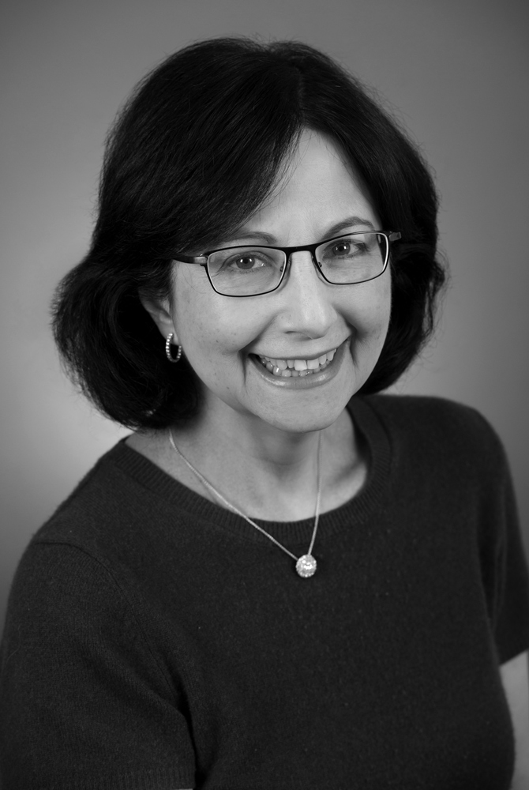
Cardiac Neurodevelopment:
An Overview
Jane Newburger, MD, MPH is one of the founders of the field of cardiac neurodevelopment. Dr. Newburger is a beloved cardiologist of many patients at Boston Children’s, and is also the medical director of the Cardiac Neurodevelopmental Program, the Associate Cardiologist-in-Chief of Academic Affairs, and the director of the Kawasaki Program.
The brain can change with learning, and full or partial recovery from injury is possible. It can be helpful to think of the brain as a muscle, which can get stronger and more able with use. Children should remind themselves:
“My growth is in my hands!” as they work to build their brain “muscle.”

Congenital heart disease is the most common birth defect and is the leading cause of mortality among all birth defects. It occurs in approximately 1% of live births, and approximately 10% of still births. Among children who have any type of birth defect, about 50% have heart disease, and there are many possible causes of congenital heart disease. Causes include genetics, infections like German measles, teratogens such as alcohol, and maternal illnesses like diabetes. However, in most cases, we do not know the cause of congenital heart disease.
For all types of congenital heart disease, survival rates have dramatically improved each decade. At this point, we expect children to survive. We have come such a long way. The very first operation was done here at Boston Children’s Hospital in 1938, and it was not until the 50’s and 60’s that the very first bypass machines were used. We began to repair heart disease in infants in the 1970’s and 80’s, and then, pioneered here by Dr. Aldo Castaneda, in newborns in the early 1980’s. We now have a burgeoning population of adults with congenital heart disease, and a shifting demographic of more adults than children with congenital heart disease in North America.
We know that behavioral, developmental, and neurological abnormalities are the most common comorbidities among children with congenital heart disease. Such challenges are more common in the congenital heart disease population than late sudden death, significant exercise limitations, significant arrhythmias, unplanned reoperations, and endocarditis combined. The prevalence of neurodevelopmental impairment is related to heart disease complexity. There is very little neurodevelopmental impairment among people with mild heart disease, such as atrial septal defects, but much higher rates among those with more severe heart disease, and among palliated newborns such as those with hypoplastic left heart syndrome. The highest rates of neurodevelopmental impairment are found among patients diagnosed with a genetic syndrome.

What causes neurodevelopmental disabilities in congenital heart disease?
There are many potential causes of neurodevelopmental disabilities among people with congenital heart disease, although we are not always able to identify a cause. Contributing factors include genetic abnormalities, fetal or in-utero environmental factors, multiple catheterizations and operations, an unstable state after cardiac surgery, a long hospital length of stay, and the associated risks of the heart disease itself, such as chronic cyanosis, stroke, and poor nutrition/growth.
Often, the same genes that cause heart defects also cause differences in brain development. Based upon our current knowledge, approximately 40% of congenital heart defects are caused by genetic changes. Some patients have an extra copy of a whole chromosome, such as with Down syndrome. Others have missing or extra parts of chromosomes, such as in 22q11 Deletion Syndrome. Still others have de novo point mutations, i.e., mutations that are absent in biologic parents, which contribute to 10% of severe congenital heart disease, according to whole exome analysis.
The cardiovascular circulation during fetal life is also important. In some fetuses with congenital heart disease, oxygen delivery to the brain is lower than normal, either because there is lower blood flow to the brain or because, as in d-transposition of the great arteries, the brain receives blue, oxygen-poor blood. At birth, the brains of full-term babies with critical heart disease are, on average, one month less mature than expected.
Open-heart surgery continues to carry some risks to brain development, although fewer risks than we once thought. Patients can have low perfusion to the brain and can have very tiny bubbles or clots that travel to the brain, both during heart surgery or during heart catheterization. However, the risks associated with those complications are extraordinarily lower than they were even twenty years ago.
The risks of anesthesia have been heavily reported in the news lately. Virtually every anesthetic agent has a black box warning now from the FDA, largely because of animal studies, but also because there are some data in humans indicating harm caused by anesthetic agents. Children who have had multiple anesthesia exposures are at higher risk for a learning disability than their age-matched peers with one or no exposures. Because some form of anesthesia is necessary for heart surgery, a great deal of research is ongoing to determine which the safest anesthetic agents are.
Another potential factor in determining developmental outcomes is the length of time spent in the hospital, and particularly in the cardiac intensive care unit (CICU). A study of children with d-transposition of the great arteries indicated that longer CICU stays in infancy were associated with lower IQ scores at age eight. A four-center study of children with hypoplastic left heart syndrome revealed that children’s neurodevelopmental outcomes were similar whether they had staged palliation to the Fontan operation versus managed by a primary intent to go straight to a heart transplant. Although surgical management i.e., single ventricle palliation versus transplant, was not predictive of outcome, the length of CICU stay after the patients’ first surgery predicted full-scale IQ, the most important determinant of lower intelligence scores was longer initial stay in the hospital. We do not know exactly what aspects of remaining hospitalized contribute to the risks, although they likely include the low blood pressure, low cardiac output, and low oxygen delivery to the brain. There are growing data from the neonatology literature to suggest additional effects on the brain from environmental toxicities during hospitalization, such as noise, pain, and exposure to plasticizers.
Heart disease itself poses risks to the developing brain. Cyanosis can compromise brain development, and children who were profoundly blue for many years before a repair have substantially worse neurodevelopmental outcomes than do children who are repaired earlier. Children with congenital heart disease are at elevated risk of strokes, both in the intensive care unit, and in everyday life.
Some strokes are silent, and can only be detected with an MRI.
The structure of the brain by MRI has been studied in the greatest depth in two groups: d-transposition of the great arteries and single ventricle. In these two groups, we have learned that changes in brain structure can begin before birth and white matter development altered even before heart surgery. Some adolescents with d-transposition of the great arteries have widespread white matter injury in areas that correspond to their observed difficulties in cognitive integration. Children and adolescents with Fontan circulation studied by brain MRI, on average, have reduced volume and thickness in their cerebral cortexes, as compared with healthy controls. The affected areas of the brain may be widespread and include the frontal, temporal, parietal, and occipital lobes, plus subcortical gray matter. A small percentage of children with single ventricle have strokes.
In summary, risk factors for neurodevelopmental disability are additive and interactive. They include innate factors such as genetics and fetal blood flow to the brain; preoperative factors such as brain maturity, low oxygen, and low blood pressure; operative procedures such as use of a heart-lung machine and anesthesia; and postoperative factors such as low blood pressure, low oxygen, use of sedatives, pain and noise, and nutrition. As a result of these many risk factors, children with complex CHD are more likely than healthy children to have atypical brain development. Finally, it is important to remember that there is a great deal of individual variation in brain structure and neurodevelopmental function. Despite their many risk factors, the majority of individuals even with critical congenital heart disease have neurodevelopmental and behavioral outcomes that are within the normal range.

The Good News: Brain Plasticity
Although the risks of brain injury associated with
CHD can be alarming, parents and clinicians should not lose sight of the good news: that the brain can change with learning, and that full or partial recovery from injury is possible. “Plasticity” refers to the brain’s ability to reorganize pathways as a result of experience. Although plasticity persists throughout the lifespan, it is especially robust in childhood, when the brain is still developing. Through plasticity, brains can change in several ways: the structure of neurons and their synaptic connections can change, and new synapses can emerge. Astonishingly, 70% of synaptic connections change each day. It can be helpful to think of the brain as a muscle, which can get stronger and more able with use. Children with CHD should remind themselves: “My growth is in my hands!” as they work to build their brain “muscle.”

Recommended Neurodevelopmental Care for Children with CHD
The American Heart Association has issued a scientific statement describing the well-established neurodevelopmental risks associated with CHD, and recommended routine neurodevelopmental screenings and assessment of all children with complex CHD. Generally, children with CHD should be evaluated at ages 12-24 months, 3-5 years, and 11-12 years, at a minimum. After age 12, an evaluation plan should be created at the discretion of the “medical home provider.” Through routine assessment, neurodevelopmental challenges can be identified early and accurately, so that interventions can be put into place that prevent the development of many more substantial problems.
Young children who fall into high-risk groups, such as those who had open-heart surgery in infancy or had ECMO, should generally be referred for Early Intervention (EI) until age three. Some children benefit from evaluation for Special Education around their third birthday to determine if they qualify for placement in a public integrated preschool. School-age children with CHD often benefit from continued Special Education services through their school districts, and young adults often require referrals to higher education and/or vocational counseling. Cardiologists should recognize that they are able to provide just one piece of the network of care required by children with CHD, and they must coordinate with, and refer to, other providers including psychologists, Developmental/Behavioral Pediatricians, Physical and Occupational Therapists, geneticists, psychiatrists, neurologists, and educators. The ultimate goal of these combined neurodevelopmental specialties is to help children with CHD to grow into adults with the best possible physical, neurodevelopmental, and social/emotional well-being.

Conclusions
Dramatic advances have occurred in the survival of patients with CHD since the advent of open heart surgery in the 1950’s. In fact, the transformation of care of the CHD patient is one of the most dramatic success stories in medicine. At the present time, nine out of ten children born with CHD survives until adulthood. One in 150 Americans has a CHD, and there are more adults than children with CHD today. However, improved survival has posed new challenges for the medical, cognitive, behavioral, and psychosocial health of this patient group.
Despite these new challenges, improvements in CHD outcomes have been extraordinary. The majority of patients with CHD are thriving, and there are more adult CHD patients with a bachelor’s or graduate school degree than patients with less than a high school degree. Future research will continue to advance our understanding of the causes, prevention, and treatment of neurodevelopmental disabilities, so that every individual with CHD can attain his or her full potential in ability, achievement and overall well-being.

Neurodevelopmental Challenges
Faced by Children with CHD
David Bellinger, PhD, helped to found the field of Cardiac Neurodevelopment together with Dr. Jane Newburger, MD, MPH, with the publication of the Boston Cardiac Arrest Trial in 2003. He is now the Research Director of the Cardiac Neurodevelopmental Program at Boston Children’s, a Senior Research Associate in Neurology, and a Professor of Neurology and Psychology at Harvard Medical School. Dr. Bellinger continues to lead research on cardiac neurodevelopment.
The strongest predictors of outcomes in children with CHD are the same as for children without CHD. The primary
factors are characteristics of the home environment, the parent-child relationship, the stimulation and the learning opportunities provided to a child.

The fact that we are holding a symposium this morning devoted solely to understanding the neurodevelopmental challenges faced by children with congenital heart disease (CHD) reflects the sea change that has occurred just in the last few years in terms of our understanding of the nature, scope, and severity of these challenges. It was not so long ago that this topic received scant attention from health professionals, and parents were largely unaware of what their child’s future might hold related to neurodevelopment. I became aware of the implications of this lack of awareness about 5 years ago, when I was giving a presentation on the topic of cardiac neurodevelopment at a conference. It was filmed, and uploaded to some websites and social media. Within a month, I began to receive e-mails that were very touching, from parents around the country who had come across the video. The following are quotes from these e-mails.
- "Up until this time I thought I was crazy in thinking that there was some connection between my son's defect and his learning issues. I finally feel like I have an answer.”
- “I sat and cried watching your video, saying 'Yes, yes, yes,' over and over again. At least I know I'm not crazy, or making up his issues."
- "You could have been talking about my son. Just wish we had been warned about this years ago. It was on this Facebook page that most of us became aware that our TGA children had some form of learning difficulties.”
- “At this point I don't know what to do, as far as ensuring that he receives the services that he needs. I've been doing a lot on my own, but I don't even know how to go about having him evaluated properly."
I learned that many of these parents had believed that once their child’s cardiac lesion was repaired, everything would be fine going forward. When their children started struggling in school, sometimes years later, the parents did not make the connection between their children’s medical histories and their current struggles. Families were largely on their own in terms of trying to figure why their children were having the difficulties they were and, most importantly, how to assist their children. Recognition of this clinical need led to the creation of the multidisciplinary Cardiac Neurodevelopmental Programs that have sprung up in recent years in many medical centers. Just as parents are encouraged to bring their children in periodically for check-ups on their cardiac health, these programs offer routine neurodevelopmental surveillance as an important component of children’s overall care.
A Overview of Cardiac ND
In this paper, I provide a very brief overview of the neurodevelopment in children with congenital heart disease.

Variability
It is important to remember that there is considerable variability in the outcomes of patients with CHD, often more variability than is seen in children without congenital heart disease. Some children do spectacularly well in their educational and occupational careers, but other children struggle. Unfortunately, we cannot explain most of this variability. There are some special circumstances that clearly place children at increased risk of neurodevelopmental difficulties, such as having a genetic syndrome, or experiencing a major event such as a post-operative seizure or a stroke, but among children free of these clear risk factors, our ability to predict who will do well and who will struggle is poor.

The Most Important Factors
The strongest predictors of outcomes in children with congenital heart disease are the same as for children without congenital heart disease. The primary factors are characteristics of the home environment, the parent-child relationship, the stimulation, and the learning opportunities, provided to a child. These are the most important predictors of outcomes regardless of whether or not a child has a congenital heart disease. What happens in the operating room explains a little bit of the variability, but it is totally overwhelmed by psychosocial, socioeconomic, and parent-child relationship factors. It is important for parents to know that what they do over a child’s early years is the most important determinant of their child’s future.

Common Weaknesses
Children with complex congenital heart disease do show certain areas of weakness. These weaknesses are often not very apparent in the first few years. Weaknesses might consist of very modest delays in gross and fine motor skills, such as sitting, standing, and walking a few months later than is typical. Children might have a modest delay in expressive language, and, for example, may not put two words together to form rudimentary sentences quite as early as some other children. Such minor delays might not be far outside of the range of normal variability for the development of these skills, however. And so, parents might think that their child is developing well in the early years. The frequency and severity of difficulties tend to increase over childhood, however, often becoming especially apparent in the middle and late primary grades.

Cognition and Neurodevelopment
General intelligence score (IQ) is generally not very helpful in telling us whether a child is having neurodevelopmental challenges. Most children with congenital heart disease score overall well within the average range on an IQ test. However, they might have difficulties in one or more specific domains of neurodevelopment. The following domains are most frequently identified as vulnerable:
- Fine motor skills
- Visual-spatial skills
- Attention
- Processing speed
- Higher-order language skills
- Executive functions
- Social cognition skills

Fine Motor Skills
A fine motor deficit might be manifested as labored and effortful penmanship. School children are still required to produce a lot of work using pencil and paper. A child with poor fine motor skills often has difficulty controlling the pencil tip to form letters and numbers accurately and neatly, so that handwriting itself requires attention that could otherwise be devoted to formulating content. Discursive writing, such as story and essay creation, might be especially impacted, because of the challenges posed by the physical aspects of production.

Visual Spatial Skills
A visual-spatial skill deficit is manifested as difficulty perceiving how parts relate to one another and contribute to the whole. A child might tend to get lost in details and have difficulty appreciating the “big picture.” It is known that attention is frequently problematic for children with CHD, with both parents and teachers reporting difficulty staying on task. In fact, it is estimated that they are 3 to 4 times more likely than their peers without CHD to meet criteria for a diagnosis of Attention Deficit Hyperactivity Disorder. Processing speed, which refers to the pace of work output, is sometimes reduced in children with CHD. Many parents report that evening homework is a challenge, and that it takes longer for the child to do what seems to be a fairly straightforward tas

Language
Some children with CHD have difficulty with higher order language skills, and they may have trouble telling a story, and using language appropriately and instrumentally in social interactions. Typical stories include multiple details organized into a coherent structure, with a clear beginning, middle, and end. If a child tends to get lost in the details, they may instead produce a story that is disorganized and difficult to follow, or they might assume incorrectly that the listener already knows information that is necessary for comprehension.

Executive Function
Executive functions refer to a cluster of higher order cognitive skills that can be likened to the CEO of a company. The CEO sits at the top of a complex organizational structure, knowing all the pieces that have to be coordinated in a certain way in order to achieve company goals. In the case of children, executive functions are the abilities to manage time efficiently, to prioritize, and to plan and organize, and also a child’s ability to regulate his or her own behavior. Self-regulation includes keeping emotions on an even keel, and inhibit inappropriate behaviors. Because executive function includes many dimensions, dysfunction can be manifested in many different ways. A child might have difficulty initiating and persisting on tasks through to completion, multitasking (i.e., rapidly switching focus and responding appropriately), holding information in mind while manipulating or transforming it in some way (referred to as working memory), formulating problem-solving strategies and then modifying the strategies in response to feedback, and integrating past experiences with present action in order to be able to anticipate the consequences.
These diverse executive function skills are increasing called upon as children progress farther in school. Whereas parents, and then teachers, provide much of the organizational scaffolding for children’s behaviors in the early years, once children pass beyond the early grades, they are expected to assume greater responsibility for organizing and prioritizing their activities, planning and executing long-term projects, keeping tabs on the progress of multiple ongoing projects, and self-regulating their behavior. If a child has vulnerabilities with regard to executive functions, this weakness often becomes much more apparent in the later grades. Indeed, we often hear from parents of children with CHD that everything seemed to be going fine for the first few grades, but then began to fall apart.
Our group has conducted several studies of adolescents with complex CHD, and we have found that both parents and teachers identify higher rates of executive function problems than within a typical population, with teachers noting more concerns than parents. In fact, according to the teachers’ ratings, almost 50% of adolescents had scores in the clinical range in their ability to plan and organize. Perhaps executive dysfunction is more evident in a highly-structured school setting which may have stringest standards for behavior. When adolescents themselves completed the same questionnaire, they indicated that they thought that they were doing pretty well and reported rates of executive problems that were essentially the same as those reported by adolescents without CHD. We do not know why there is such a discrepancy between teacher reports and self-reports, but one hypothesis is that the adolescents lack insight into their strengths and limitations.

Social Cognition
Social cognition has only recently been identified as a common problem for children with complex CHD. Social cognition describes how cognitive processes are used in understanding other people in social situations. It includes, first, the ability to understand that other people have beliefs, desires, intentions, and perspectives that are different from one's own, and second, the ability to attribute mental states, beliefs, and motivations. Essentially, social cognition is the ability to put yourself into another person's shoes, to infer what they know, what emotions they are experiencing, and what their intentions are. This skill is referred to as having a “theory of mind.” It is not difficult to see how critical theory of mind is in terms of an individual’s ability to establish and maintain good relationships with other people.

A Combination of Impairments
We sometimes focus on neuropsychological deficits in isolation from one another, but it is important to appreciate that they are not independent from one another, nor are they independent of a child’s social and psychiatric status. For example, neuropsychological weaknesses such as poor language or attention can also affect the peer relationships and interactions of children with CHD. To review, their most frequent neuropsychological weaknesses of children with CHD include: reduced cognitive processing speed, executive function (particularly working memory and shifting), social cognition (recognizing other people’s emotions), and higher order language. The latter include the interpretation of non-literal constructions in which what is spoken does not reflect the underlying meaning that the speaker actual intends to convey.
Consider the demands of adolescent peer-peer interaction in light of these weaknesses. Typical adolescent conversation is very fast-paced, often taking a telegraphic form in which just a few words convey a complex meaning that the listener must recognize in order to understand. Conversation is also affect-rich, with rapidly shifting allegiances that must be updated regularly in order to avoid committing a faux pas. And language is often pragmatically very complex, involving the use of indirect, non-literal constructions such as sarcasm, innuendo, insults, and deception.
The slow information processing speed of a child with CHD makes it hard for them to adapt to rapid changes in conversational topic. Underlying difficulty in identifying the meanings of facial expressions and non-literal language can make it hard for children to interpret highly affect-laden speech. Since adolescent friendships and relationships often shift rapidly, an adolescent needs good cognitive flexibility and working memory in order to avoid social blunders. The frequent use of pragmatically complex language requires adolescents to be adept at reading others' emotions and intents, and to be able to understand other perspectives. Deficits in one or more of these social cognitive skills increases the challenge of finding a peer group in which the adolescent can fit in comfortably.

Conclusion
It is now apparent that neurodevelopmental surveillance should be considered a routine component of the follow-up care for children with CHD. Just as children return to their cardiologist for periodic heart check-ups, they should also come back for periodic neurodevelopmental check-ups. Through such regular surveillance, emerging problems can be identified early, and timely interventions can be implemented before problems problem becomes so severe that the quality of life of the child and family is reduced.

Congenital Heart Disease in the
Family System
Boston Children’s Psychiatrist-in-Chief, David DeMaso, PhD is committed to understanding the psychiatric profile of children with CHD, and to supporting the development of healthy children and healthy families. One of his current areas of focus is establishing a better understanding of the development of those with Fontan circulation.

Congenital Heart Disease (CHD) is a constellation of disorders that affects approximately 1 in 100 children born. The disorders vary widely in their complexity and expected outcomes, ranging from minor defects that resolve spontaneously, to life-threatening conditions. Approximately a quarter of CHD cases require interventions such as surgeries or catheterizations. Thanks to remarkable medical advances in the past decades, most babies born with CHD today will now survive into adulthood. Approximately 90-95% of babies born with mild or moderate lesions will survive, and approximately 80% of those born with severe lesions. As a result, for the first time in human history, there are now more adults than children living with complex CHD.
A parent’s adjustment to, and perception of, CHD are highly predictive of a child’s ability to adjust emotionally to their illness, and are in fact more predictive than the severity of the illness itself.

Stressors and Resilience
From prenatal diagnosis through adulthood, people with CHD and their families are faced with numerous stressors that can negatively impact their day-to-day functioning and their long-term development. These stressors can be grouped into three categories: direct medical effects, indirect emotional and behavioral responses, and impact on the family. Many children with CHD require multiple surgeries, chronic medications, and even heart transplantation. They may face frequent and long hospitalizations as well as activity restrictions. They may struggle with difficult emotional responses and/or behavioral distress after medical interventions, which, depending on the case, can last for hours, days, months, or even years. Developmental, behavioral, and learning challenges are common among children with CHD, especially among those with more complex or severe heart lesions.
The symptoms and treatment of CHD pose substantial challenges to families. Parents and other significant caretakers bear the burden of day-to-day management of a complex illness, and they experience the stress associated with the pain and potential loss of a loved one. Siblings, other relatives, and friends are also affected to varying degrees by the patient’s physical illness, by any associated emotional or behavioral challenges, and by parental stress.
Despite the enormous challenge posed by CHD, most children and their families are remarkably resilient, and the majority of families do not have any disabling behavioral health (BH) difficulties. Family members tend to be most resilient when they have high levels of both self-understanding in combination with attunement to the perspectives of other family members. Many factors influence a child’s response to stress, including coping styles, developmental level, temperament, illness severity, prior experiences, medical caregiver behavior, and level of family distress. Each child’s unique profile of risk and protective factors helps to determine how that child will respond in the face of illness and treatment. In order to support families, providers must be attuned to the risk factors associated with distress related to CHD, and adopt a general policy of hoping for the best, and planning for the worst.

Coping Styles
Coping is a set of cognitive, emotional, and behavioral responses to stressors, and involves the consistent use of particular strategies for managing stressors across contexts. Coping styles are dependent on resources including problem solving skills, social skills, social support, health and energy, positive beliefs, and material resources. A child’s coping style is also shaped by temperament, developmental level, and family coping patterns.
Coping styles can be understood along several dimensions, including approach versus avoidance orientation, and problem versus emotion focus. Approach-oriented coping is characterized by seeking medical information, medical play and the active seeking of emotional and social support. By contrast, avoidance-oriented coping involves going to sleep, daydreaming, and refusing to ask or answer questions. People with problem-focused coping styles are driven to “fix it.” Emotion-focused coping is centered on managing emotional responses to the stressor, and can be characterized as, “deal with it.” No one coping style is consistently associated with better outcomes. Instead, the most critical factors in determining effective coping is whether a child has a coping “plan,” and the frequency and flexibility with which the child can use the strategies in his or her plan. Coping usually improves with age and development.

Developmental Level
Children’s responses to stress are also shaped by their developmental level. Since children with CHD are at a higher risk of intellectual disability, developmental level is not always commensurate with chronological age.
During preschool, children are less likely to understand preparatory information, so they have a limited ability to anticipate planned procedures or hospitalizations. Young children are generally not able to use self-generated adaptive coping strategies, and are more dependent on adults for soothing and self-regulation. By middle childhood, children have an increased ability to understand information about their condition and treatment, though they remain prone to misinterpretation. Given their increasing capacity to understand interventions and/or treatment, they are more vulnerable to worrying about procedures or operations. On the positive side, children at this level of development are able to learn and use coping cognitions and emotion-focused coping strategies.
Adolescents’ emerging capacity for abstract thinking brings new vulnerabilities and new strengths, as they experience greater fears about their long-term outcomes, but also become able to draw upon a wider range of coping strategies.

Temperament
A child’s temperament (or nature or makeup) can influence his or her ability to manage the challenges associated with CHD. For instance, children with anxious temperaments are at increased risk for behavioral distress. While only 60% of anxious children are uncooperative in acute
medical situations, many are at risk for becoming uncommunicative and withdrawn in anticipation of events, or afterwards. In the short-term, the presence of an anxiety and/or depressive disorder can exacerbate distress behavior, and in the long-term, untreated anxiety and/or depression is associated with avoidance and medical non-adherence.

Medical Severity
Another factor shaping a child’s emotional response to CHD is the severity of the disease itself. The course of CHD disease and treatment is highly variable. Risk factors for poor adaptation include episodes of acute pain in a novel environment, and a complex and/or unpredictable treatment course. Furthermore, more severe CHD lesions are associated with abnormal MRI brain findings, and with increased incidence of deficits, including impaired attention, memory, executive function, motor skills, and visual-spatial skills. Diseases and treatments that affect the central nervous system also increase risk for behavioral health disorders, including anxiety and depression.

Prior Experiences
A child’s prior experience with treatment is central in forming this or her reaction to new events. Children who have a history of painful, frightening, or unsuccessful medical experiences often anticipate similar experiences in the future, and experience anxiety as a result. Since behavior is determined by anticipated consequences, patients and families with a history of negative medical experiences are at risk for delaying necessary treatment, which can lead to unnecessary complications, more complex interventions, and negative outcomes.

Medical Provider Behaviors
Medical providers can play a central role in determining a child’s emotional response to treatment. They often unknowingly engage in behaviors that either increase or decrease a child’s risk of poor adaptation. Medical providers must find a delicate balance between acknowledging a child’s experiences, but not amplifying them. Children can respond poorly to excessive explanation and reassurance during procedures, since these well-meaning behaviors may unwittingly validate and magnify aversive experiences. However, denial and minimization of expressed fears is similarly ineffective, and may erode trust. Any episodes of coercion, coaxing, threats, or insults are particularly damaging, and tend to escalate a patient’s fear-related behaviors. Medical caregivers are able to help build patient resilience when they establish supportive long-term relationships with children and their families, and when they appropriately anticipate and respond to children’s emotional needs in the context of their development.

Family Distress
Since children exist within a family system, their experience of CHD is centrally influenced by the experience of their families. All families with CHD face fear, and must learn to manage it. Parents often intensely experience the vulnerability of their child, and they must learn to cope with their inability to protect their child from the disease. Parents often express fears about survival, poor outcomes, and alteration of lifestyle, which can be manifested as symptoms of anxiety, depression, guilt, or even anger.
Parents of children with CHD are obliged to
surrender their sense of control, and they may need to forsake their traditional caregiver roles when their children are hospitalized or undergoing treatment. Many parents become preoccupied with medical details, and may underemphasize issues related to psychosocial functioning. Parents often describe being on an “emotional rollercoaster” without knowing when they will get off, and many parents experience symptoms of PTSD including numbness, intrusive thoughts, and hyperarousal.
Parents caring for children with CHD are faced with many stressors, both short-term and long-term. For instance, during a hospitalization, parents are usually most focused on the medical prognosis, and with likely effects of both the illness and its treatment. After discharge, worries about their children’s quality of life, especially when a complete medical repair is impossible, and when a child experiences cognitive, social/emotional, learning, or behavior challenges, become more prominent. As a child gets older, parents often become increasingly concerned about psychosocial functioning, including their child’s emotional and social adjustment.
Concerns about the functioning of the whole family are not uncommon, as a serious illness can have profound effects on family life, relationships, and the emotional functioning of siblings. Finally, most parents worry about the financial repercussions of managing a complex and life-long illness, especially when one or both parents must relocate, leave work, or alter their work hours to accommodate the needs of the ill child. Like all complex illnesses, CHD presents substantial financial costs to families, both in the short-term and the long-term, and meeting these costs is often very challenging. In order to successfully adapt to these multiple concerns, parents of children with CHD must develop a good understanding of the illness and its treatment, and recognize its potential complications.
Parental adjustment to, and perception of, CHD are highly predictive of a child’s ability to adjust emotionally to their illness, and are in fact more predictive than the severity of the illness itself. As with medical caregivers, parents can develop resilience in their children by modeling a calm presence, and by carefully balancing between providing excessive reassurance, and minimizing a child’s fears. Unfortunately, parents are often traumatized themselves, and in triggering situations they may struggle to meet their children’s emotional needs, instead unwittingly communicating their own anxiety to their children.

Managing risk: the 4 A’s
Medical providers can help families to adjust adaptively to CHD, and to build resilience in the face of fear and uncertainty, by remembering the “Four A’s”: Assess, Advise, Assist, and Arrange.
Assess: Early identification and early intervention are critical when trying to prevent the problems associated with heightened family or child distress. Medical providers must be aware of aforementioned risk factors, and must be alert for signs that a child or family is struggling.
Advise: Medical providers need to provide appropriate and accurate psychoeducation for parents, helping them to develop an appreciation of their and their child’s emotional challenges, and strategies for managing them. Medical providers should advise parents to be open, honest, and age-appropriate in sharing information with children, and to treat children in ways that are predictable and consistent. Parents can be reassured that showing feelings is normal and helpful, and they should encourage this openness in their children. Medical providers can help parents to understand the need to balance developmental and medical demands in their children, and to feel confident in encouraging developmentally appropriate self-care.
Arrange and Assist: When medical providers have determined that a child or family is experiencing disabling or troubling distress, they should help connect the family to appropriate behavioral health treatment or other resources. When a child and family are anxious about an admission or procedure, they may benefit from pre-admission interventions that build comfort, confidence, and coping strategies. Parents or children may require supportive counseling or other therapies. Medical providers can begin this process by classifying the identified behavioral health concerns as mild, moderate, or severe, and then make referrals accordingly. All children with complex or severe CHD should be referred for neurodevelopmental screening or evaluation to identify the possible presence of developmental delays or disorders.
Children with CHD are at elevated risk of mental disorders such as ADHD, behavior and conduct problems, anxiety, depression, and Autism Spectrum Disorder (ASD), such that approximately a third of children with complex CHD meet criteria for one or more diagnosis. Behavioral health treatments are available for all of these disorders, and medication treatments may be effective for several of them. Early evidence suggests that many children with both CHD and ADHD are positively responsive to treatment with a stimulant medication, but no comprehensive research has yet been completed, and any use of medication must always be prescribed in consultation with a cardiologist. While informal surveys suggest that most cardiologists permit a stimulant trial in patients with CHD and ADHD, caution is indicated among patients whose physiology could be compromised by increases in heart rate and blood pressure. Medication management of anxiety and depression may prove helpful for some patients with CHD, though there is not yet sufficient research on either effectiveness or safety in this population to recommend it definitively.

Conclusion
CHD poses substantial risks for behavioral health functioning, both in individuals, and in the family system. Children with CHD, particularly those with complex or severe lesions, have increased incidence of mental disorders including ADHD, anxiety, and depression. These problems are often more difficult to treat when children are additionally struggling with risk factors such as neurodevelopmental impairment or family distress. Medical providers and families should be aware of risk factors for poor adjustment, including poorly-organized coping skills, an anxious temperament, risks specific to certain developmental stages, severe illness and complex treatment, a history of negative medical experiences, high levels of family distress, and maladaptive provider behaviors. Children with these additional risk factors should be assessed regularly, and provided with timely and appropriate intervention in order to promote health and wellness. Despite the numerous challenges facing those with CHD, children and families all have the capacity for resilience and healthy behavioral health functioning, and medical providers can help to support their positive adaptation to the stressors related to CHD.

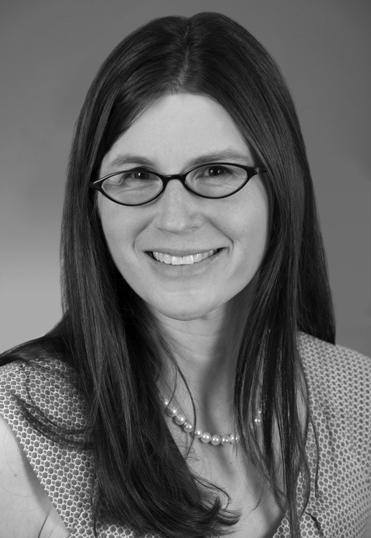
Individual Learning
Styles in CHD
Catherine Ullman Shade, PhD, MEd, is the director of Education at Boston Children’s Cardiac Neurodevelopmental Program, where she works to understand the learning needs of children with CHD, and to make sure they are receiving an appropriate education. Dr. Ullman Shade is also committed to spreading awareness of CHD within the broader community, so that teachers, pediatricians, and other providers are prepared to treat children with CHD with knowledge and compassion.
About 1/3 to 1/2 of children with complex CHD receive special education programming, 7-15% are placed in a substantially-separate classroom, and 18% are retained in a grade. Deficits can be impairing and even debilitating, but happily, they can also be effectively mitigated through targeted, timely, and evidence-based services and interventions.

Introduction
Although the mind and the heart are popularly imagined to be polar opposites, they are in fact intimately and irrevocably linked, and problems in the heart can lead to problems in the brain. Children with complex congenital heart disease are more likely than their peers to experience low oxygen saturation, seizure, stroke, anesthesia, long hospitalizations, poor growth, and multiple prolonged surgeries, all of which pose real risks to the developing brain. As a result, children with complex congenital heart disease as a group have lower cognitive profiles than healthy peers.
Given the risks of brain and cognitive differences among children with congenital heart disease, it should not be surprising that they are more likely than their typically-developing peers to experience learning challenges. Approximately ⅓ to ½ of children with complex CHD receive special education programming, 7-15% are placed in a substantially-separate classroom, and 18% are retained in a grade.. Children with more complex medical histories are at particularly high risk of learning challenges, including children with histories of cyanosis, single ventricle physiology, seizure, stroke, ECMO, and those who have underlying genetic conditions.
Though every learner is unique, we can identify a profile of academic impairment that is often observed in learners with CHD. Children with CHD frequently struggle with attention, executive function, integration and synthesis, visual-spatial skills, and writing, each of which can broadly affect functioning in multiple aspects of the curriculum, and throughout a child’s development. These deficits can be impairing and even debilitating, but happily, they can also be effectively mitigated through targeted, timely, and evidence-based services and interventions.

Attention and Activity
Children with CHD have increased incidence of ADHD, which can result in reduced engagement with instruction, and limited ability to complete assignments. In addition to missing learning opportunities due to inattention, children with the Combined subtype of ADHD are also more likely than typical peers to miss classroom time due to behavior problems and the resulting disciplinary actions. Children with ADHD often struggle to demonstrate their learning effectively, since they are prone to careless errors and impulsive responses, both of which can lead to grades and test scores that underestimate a child’s true understanding.
ADHD can be effectively managed in most children using evidence-based behavioral and/or medical treatments. Parent training is highly effective, in which an expert in child psychology teaches parents how to support more positive interactions with their child, promote wanted behaviors, and reduce unwanted behaviors. At school, a daily report card is a simple intervention in which teachers send home a report of how well a child performed on specific behavioral goals that day. Classroom accommodations can help children to attend to instruction, and to better engage with classroom activities. Though there is scarce empirical evidence of their efficacy, accommodations such as priority seating, “wiggle seats,” and frequent motor breaks appear to help many children. When behavioral interventions are not effective at adequately managing a child’s ADHD symptoms, doctors may recommend medical management. Most children with CHD can be safely treated with ADHD medications, but parents considering medication should check with the child’s cardiologist to ensure that the medications are safe for their child. Many children with CHD are treated safely and effectively every day, and for these children the risks of medical management are generally outweighed by the benefits.

Executive Function
Executive function can be broadly considered the “CEO” of the mind, and it includes the functions of inhibition, working memory and cognitive flexibility. At least one element of executive functioning is impaired in 75-81% of children with severe CHD, which is twice the prevalence in the typical population. Children with executive functioning challenges often experience difficulty at school, and these problems may become more pronounced as they progress through the grades, and face increasing demands and expectations for independence. Students with executive function challenges often struggle to switch among academic tasks, to appreciate and analyze multiple perspectives, and to adapt to changing expectations. This reduced flexibility can be particularly impairing when children begin changing classrooms in middle school. They often struggle to plan their learning and to monitor their progress, which renders long-term and open-ended assignments such as term papers particularly problematic. Organization is often impaired, which becomes increasingly relevant in later grades when children manage the materials and demands of multiple classes. In addition, many children display impulsive and disproportionate emotional responses that can interfere with their learning, and with their experience of school.

Integrating Big Ideas
Another common area of deficit among learners with CHD is in the ability to synthesize and integrate information, and to recognize underlying organizational structures. Children with CHD often rely overly on details, and fail to perceive the overall gestalt of information. Using Bloom’s model of the levels of thinking, children with integration impairment are most capable when tasks require thinking at the knowledge, comprehension, and application levels, and struggle with tasks requiring higher-order thinking such as analysis, synthesis, and evaluation. This limitation can be impairing in multiple school activities and
subjects, including recognizing
patterns and rules in math and science, identifying themes or main ideas in a text, focusing on a thesis or topic in writing, and drawing conclusions across texts and subjects. Since higher-order thinking is increasingly expected as students progress through school, a deficit in integration and synthesis may become more pronounced and impairing in the later grades.
Children who face challenges with integration and synthesis are often capable learners, but they generally require direct, systematic, and explicit instruction across the curriculum in order to be successful in drawing conclusions, recognizing patterns, and categorizing information. For example, while a typical learner may see multiple examples of addition and subtraction facts and induce that the functions are the inverse of each other, a child with a deficit in integration may never make this connection without explicit instruction. Teachers should use a linear curriculum with such learners, since students may struggle to synthesize information that reappears across time and contexts. When reading, children with integration impairment will often need structured support in how to identify the main idea of different genres of text, including instruction in strategies such as recognizing and using text features, and looking for recurring words. When writing, children require scaffolding such as graphic organizers in order to determine the relationships among their own ideas, and to pull out their big points.

Visual Spatial Skills
Studies of cognition among children with CHD consistently reveal a relative weakness in visual spatial skills, which may be particularly pronounced among children with Tetralogy of Fallot or single ventricle physiology. Children with visual spatial weaknesses usually struggle with organizing, remembering, recognizing, and reproducing visual information. This weakness affects a variety of academic tasks, crossing multiple subject areas, including geometry, interpreting graphs and charts, copying notes off a board, using number lines, making and understanding maps, organizing work on a page, and interpreting graphic organizers.
For children with visual spatial deficits, the old adage that “a picture is worth a thousand words” is turned on its head, and children may be much more successful at processing verbal information than visual information. Teachers can show students how to verbally mediate visual information so that they can recognize patterns and interpret content. For example, students should interpret graphs by describing what they are seeing, and turning it into a “story” or a verbal description of trends. They may want to rewrite the information contained in a graph in narrative form in order to understand and appreciate its import. When producing or reproducing shapes, or organizing material on a page, students should learn to verbally narrate the process, and to rely on explicit rules. For example, they might remember that the “first math problem goes at the top and on the left, an inch from the corner of the page,” and when drawing a triangle they may narrate, “one side, two sides, three sides.” Such verbal mediation can compensate for students’ difficulty in recognizing patterns and information visually. As students gain more independence, they can often request and reproduce course content in a modality that is easier for them to interpret.

Writing
Writing is challenging for many learners with CHD, even when their reading is intact. Some of this relative impairment can be explained by the nature of writing itself, which is a more complex and challenging process than reading. Writing relies on recall and retrieval of information and has no supportive context, while reading relies primarily on recognition and generally includes a contextual scaffold. Furthermore, children learning to read and write in English must contend with more complicated grapheme-phoneme correspondence patterns when writing than when reading. In addition to the inherent relative difficulty of writing for all learners, writing also poses unique challenges for many learners with CHD. Writing requires the seamless integration of multiple skills that are often impaired in this population, including fine motor coordination, word retrieval, sustained attention, and the synthesis and organization of ideas. Many writers with CHD face multiple areas of deficit, and as a result their writing is often slow, effortful, and poorly-organized.
Since writing deficits among learners with CHD are often multi-faceted, they usually require a similarly multi-faceted approach to remediation. When handwriting is impaired, children often benefit from Occupational Therapy (OT), and from explicit, systematic, and multisensory handwriting instruction. Many children find it easier to type than to hand write, and their fluency and output increase when they are given access to a computer for writing assignments. Some students do best when they can use an assistive word processor or speech-to-text software, particularly when they struggle with substantial fine motor challenges or a language-based learning disability. Explicit grammar instruction can teach children how sentences are formed, so that they can learn to construct well-formulated sentences of varying structures, while using conventional writing mechanics. As students move towards writing longer compositions, they benefit from explicit instruction in how to use a repertoire of graphic organizers to generate and structure their ideas within multiple genres. They should learn to deconstruct the act of writing into manageable steps or “chunks,” and then should use an external organizing structure to plan and executive each step.

Meeting Learners Where They Are
While it is helpful to identify services and accommodations that can enable individual students to find success within the classroom, it may ultimately be more productive to consider how to redesign the class itself so that it is accessible to all learners from the outset. Based on Universal Design within architecture, Universal Design for Learning (UDL) proposes that teachers can design learning environments that allow choice and differentiation among all students, and that can inherently accommodate variations in ability and interest. When using a UDL design, teachers are encouraged to clearly define the learning goal of each class, and then to identify and make available multiple paths towards that goal. For example, if a teacher’s goal is for students to compare and contrast ancient Sparta and Athens, students could choose to meet this goal by writing an essay, creating a Venn Diagram, making a T-chart, giving an oral presentation, drawing a comic, or filming a video or animation. A UDL approach to instructional design has multiple benefits for all learners, by increasing engagement, developing metacognition, reducing stigma associated with variations in ability, and limiting the provision of supplemental and recuperative services. Many of the learning challenges associated with CHD could be substantially lessened within the context of a well-run UDL classroom.

Conclusion
When a child is born with complex CHD, parents and providers appropriately focus on survival for the first days, weeks, and sometimes years of that child’s life. We are blessed to live in an age when most children with CHD survive to adulthood, and the wonder of this accomplishment is inestimable. However, as survival is now expected, and as the number of adults living with CHD eclipses the number of children, we must acknowledge that while survival is extraordinary, it is not enough. Many children with CHD are physically healthy, but emotionally or psychologically fragile, and these children all too often experience devastating failures at school. While adults benefit from the perspective that school is just a single and finite part of life, children often perceive school as their single and all-consuming “job,” and when they feel unsuccessful at school, they often conclude that they are “stupid,” worthless, or “bad.” So while school failure is not literally life-and-death like heart failure, it is high-stakes, and children’s self-concept and happiness often rest in large part on their perception of their ability and experience at school. As parents and professionals who care for children with CHD, we need to recognize that all children can learn, and we need to resolve to ensure that this possibility is realized. We must screen academic achievement early, monitor progress regularly, intervene early and aggressively when deficits are identified, and develop individual education plans that capitalize on children’s strengths, work towards their unique goals, and remediate weaknesses. Finally, our responsibility and our mandate as educators are to meet children where they are, and to bring them as far as they can go. Through this mindset and approach, we can help enable children with CHD not just to survive, but to thrive.

Special Education Law:
What You Need to Know
Daniel Heffernan, JD, is a partner at the law firm Kotin, Crabtree, and Strong, and is one of the region’s foremost experts on special education law. As the parent of a son with special needs, Heffernan approaches his clients with unique understanding, and he has helped many children with disabilities to attain the appropriate educations to which they are entitled.

Precursors of Special Education Law
Parents need to identify the experts in the issues that are most important to their child’s education, and use those experts to support their case. When they understand the special education process, parents can appreciate the proper role of an attorney or advocate, and can determine when to get them involved in the process.

Special Education grew out of the Civil Rights Movement of the 1960s, and concerns about unequal access to education, including public education. The first attempt to encourage education of children with disabilities were federal laws in 1966 and 1970, which amended the Elementary and Second Education Act to establish grant programs, but not individual entitlements. These grants were intended to assist states in the education of “handicapped children,” but included no specific mandates, and there was little evidence of their success. The 1954 Brown vs. Board of Education case is another important precursor of Special Education law. By establishing that segregating students based on race is impermissible, Brown laid the groundwork for the “Least Restrictive Environment” language of IDEA, which requires that children not be separated from their peers unless it is demonstrated that they cannot be effectively educated in the mainstream environment.

IDEA and other education laws
1975 marked the enactment of the Education for Handicapped Children Act, which is now known as the Individuals with Disabilities Education Act (IDEA). It was most recently authorized in 2004, effective 7/1/2005. Unlike its predecessors, IDEA entitles children with disabilities to Free and Appropriate Public Education (FAPE). Section 504 of the Americans with Disabilities Act of 1990 provides further protection for children with disabilities seeking equal access to education. In addition to the federal laws, multiple state laws also affect children with disabilities, such as Chapter 766 in Massachusetts, which guarantees all children with disabilities ages 3-22 to an education program suited to their needs. States that accept federal funding for special education must comply with IDEA, but they may also choose to grant more extensive substantive or procedural rights to students.
FAPE
IDEA requires that every child receive a Free and Appropriate Public Education (FAPE) that provides a meaningful benefit to the child. The education program must meet the unique needs of the child, and must be provided at public expense. IDEA prohibits blanket reduction or elimination of services due to type of disability, or any change of law. Under FAPE, courts have ordered that states offer, “an extensive array of special education services,” including private day and residential facilities, and that services must always be appropriate to meet a child’s needs. According to FAPE, educational programs must be determined based solely on child need. A child’s program may not be determined due to disability category alone, nor may it be based on the cost or current availability of classrooms, service providers, or programs. School district policies or procedures may not be considered if they conflict with FAPE, nor can questions of administrative convenience.

Least Restrictive Environment
Under IDEA, a child with a disability must be educated to the maximum extent possible and appropriate in the “Least Restrictive Environment” (LRE). The more separated from non-disabled peers, the more “restricted” an environment is considered. Removal from the regular education environment can occur only when the nature or severity of the child’s disability is such that, “education in the regular environment with the use of supplementary aids and services cannot be achieved satisfactorily.” Given LRE, school districts or parents who want to move a child to a more restrictive setting face a strong presumption against such a change. Highly restrictive environments such as specialty schools are generally very costly for school districts, which can provide districts with a further incentive to attempt to educate children in a less restrictive setting. For example, in Massachusetts, private schools serving children with disabilities range in tuition from about $38,000/year for the Carroll School, to about $327,000/year for the NECC Severe Residential Program.

Parent participation in IDEA
IDEA offers myriad provisions for parent participation in the special education process. Parents are considered a member of the special education team, and provide input into the creation of an education plan. Once a plan is written, parents can determine whether or not to accept it. Parents are also required to be notified at set stages of the special education process.

Special education process
The special education process includes six steps. First, the child is referred, and then is seen for an evaluation. After the evaluation, the special education team meets to determine whether or not the child meets eligibility requirements for special education. If the child is found to be eligible, the team creates an Individualized Education Plan (IEP), which includes both goals and services, and determines the child’s educational placement. If either party is unsatisfied with the result of the team meeting, they may appeal to administrative proceeding, and if that process does not result in a resolution, they may appeal to court.

Referral
Any parent, caregiver, or professional may refer a child for an initial evaluation. After receiving a referral, a school district cannot refuse to conduct an initial assessment.

Evaluation assessments
When a child is initially evaluated by a school district, the evaluation must include assessments of educational history, overall progress, and current standing, including information from the current teacher. Evaluations should also include discussion of attention, participation, communication, memory, social functioning, and educational and developmental potential. All areas of suspected disability must be assessed, which may
require speech/language, Physical Therapy (PT), and/or Occupational Therapy (OT) evaluations. Other forms of assessment are optional, and their use varies by school district and student. For example, psychological, health, and home assessments may be included. The team is required to review existing evaluation data in advance of their meeting for re-evaluations, and, if appropriate, for initial evaluations, in order to determine what additional data is needed.

Determination of Eligibility
After an initial evaluation, a student’s IEP team meets to review the evaluation results. This meeting must take place within 45 school days of the district’s receipt of consent to perform the evaluation, which translates to within 15 school days of the completion of the evaluation. At the meeting, the team determines whether or not a child is eligible for an IEP, and if the child is eligible, the team determines placement and services, and provides an IEP document.
A student should be determined eligible for special education if s/he has a disability, is not making effective progress in school due to the disability, and requires specially designed instruction or related service in order to access the regular curriculum.

Related Services
If a child requires a service in order to have access to FAPE, then the school district must provide the necessary services. For example, the 1984 case Irving School District v. Tatro revolved around a student with Spina Bifida who could not attend school without clean intermittent catheterizations that did not need to be provided by a doctor. These catheterizations were deemed a “related service,” since they were required for school attendance. The 1999 case Cedar Rapids v. Garret F. was an extension of Tatro, and determined that a school district must provide trained nursing personnel to attend to the needs of a ventilator-dependent student.

IEP’s
When a child is found eligible for special education, the team develops an Individualized Education Plan (IEP), which is a binding contract, and which contains multiple distinct sections. IEP’s begin with parent/student input, including both the vision for the child, and concerns. Next, an IEP identifies the student’s areas of need, describes the child’s existing performance levels, and explains how the child’s disability affects progress. One or more measurable annual goals are identified and listed, which must be “challenging but attainable” for the student within the IEP period. Under Massachusetts law, IEP’s must include benchmarks and objectives specifying what the student needs to do in order to meet each goal. Benchmarks and objectives are not required by IDEA 2004, however, except for students who take alternate assessments. A service delivery grid describes the services that the child will receive, including their setting, frequency, and type of personal. Services must be “based on peer-reviewed research to the extent practicable.” IEP’s can also include a list of necessary accommodations.
After receiving an IEP from a school district, families are called upon to respond. They may choose to accept or reject the entire IEP, or to accept and reject it in part. According to the “Stay Put” provision, if a parent disputes a proposed IEP change, the child may remain in his/her current placement until the dispute is resolved.

Individual Healthcare Plans
An Individual Healthcare Plan (IHP) can stand alone, or it can be attached to, or incorporated into, either an IEP or a 504 Plan, in which case it becomes a binding contract. School nurses are responsible for developing IHP’s in collaboration with the student, family, and healthcare providers, in situations when the student’s healthcare needs affect, or have the potential to affect, safe and optimal school attendance and academic achievement. The school nurse uses the IHP to coordinate care, facilitate health management in the school setting, and inform educational plans.

504 Plans
Section 504 of the Rehabilitation Act of 1973 prohibits discrimination and exclusion in all programs receiving federal financial assistance, including public schools. It guarantees equal access to public schooling, and requires that students with significant and impactful disability be entitled to reasonable accommodations. A 504 Plan is a document that describes the accommodation a child with a disability requires in order to establish equal access to public schooling.

Dispute Resolution
Parents can choose to accept or reject IEPs in whole or in part. When the IEP team is unable to resolve a dispute about an IEP, either party can choose to move to mediation. The mediator is a neutral party, and mediation sessions are voluntary. When a resolution cannot be reached during mediation, then the dispute may move on to litigation and eventually to a hearing. Special education hearings are rare, and nearly all disputes are resolved before necessitating one. For example, while 165,000 students in MA are on IEPs and 10,800 IEPs were rejected in 2016, only 568 hearings were requested, and just 23 full hearings actually took place.
Special Education Advocacy Tips
Families can be most successful in securing an appropriate education program for their children if they keep in mind the following tips:

- “You’re married to a church that doesn’t recognize divorce.” Hearing Officer Rosa Figueroa uses this quotation to describe the relationship between school districts and parents. At the end of the day, after any dispute, the school district and the parents still have a relationship, one that will last until high school graduation, or until age 22. So, although it is important for parents not to be doormats, they should bear in mind that preserving a cordial and cooperative relationship with the school is in their best interest.

- Know who is for you and who is against you.
Families need to determine who is educated about issues that are important to them, and who is not. For example, the inclusion facilitator at a school may be someone who understands the related issues well, but the vice principal may have very little knowledge of special education.

- Experts are key.
Parents need to identify the experts in the issues that are most important to their child’s education, and use those experts to support their case. Families should always have up-to-date evaluations from the relevant experts for their child, especially if a case goes to litigation. Hearing officers may bar testimony from an expert who does not have up-to-date information.

- Know your rights and limitations.
Families should educate themselves on their rights, and what they can expect, so that they know what they can assert for themselves. Families should be aware of what school districts are, and are not, required to do, and what they can, and cannot, get from the special education process.

- The proper role of the attorney/advocate.
When they understand the special education process, parents can appreciate the proper role of an attorney or advocate, and can determine when to get them involved in the process. They should be judicious in deciding when and how advocates or attorneys may be helpful, and what type of advocate or attorney is most relevant to a particular situation.

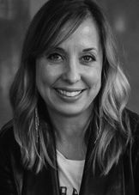
Thriving with CHD:
A Family Story
Jessica Lindberg, MBA, is the mother of four boys, including her son Ethan, who had CHD. She is the founder and a board member of the Ethan M. Lindberg Foundation, and a tireless advocate for children and families with CHD.

My name is Jessica Lindberg, and I, like many of you, am a heart parent. My oldest son, Ethan, was born with a congenital heart defect. He was prenatally diagnosed with aortic stenosis. We traveled to Boston from outside Chicago, and proceeded to have one of the early fetal interventions here at Boston Children's Hospital, involving opening the aortic stenosis in utero. I was 22 weeks pregnant at the time.
When the birthday party invitations would come, I would start sweating, thinking, "He can't do all the things other kids can do." I worried that people would think, "He's just a little different, but we can't really figure out why."

We had all of Ethan's cardiac surgeries here at Boston Children’s. In fact, we lived about two of the seven years of his life here, at the hospital. We have spent a lot of time in these four walls. It's a very, very special place to us.
During Ethan's stays here, he was an extremely happy child, and even got his own hospital ID badge. I’m sure that was totally illegal, but he had a way of talking his nurses into the things that he wanted to do. When Ethan was about three years old, we were at the hospital for a visit. I was sharing some of my concerns about executive functioning, math, puzzles, and potty training. I was already doing so many therapies for Ethan, and I couldn't believe that now I had all of these other things to worry about.
One of the doctors recommended, "You should meet with Dr. Ware." So, we went to meet Dr. Janice Ware, and she kindly spent about two days with Ethan. We sat down the next day, and I still remember her office so well. There was the little window, and the desk, and all these books. I was sweating, because I was waiting to see what she was going to tell me. She described all of these skills that we had to work on. I was like, "Oh my goodness." I had already quit my job that I loved. I had given up grad school that I loved, and I was so dedicated to this child. I was really kind of upset with her at first, to be honest, because I was thinking, "How dare she tell me there's more work to do?"
We went home, and decided to refocus. I cried for a couple of days, and then we really targeted the things that Ethan needed to work on. About a year later, we went to meet with his teacher at his school, and I brought out Dr. Ware’s report. I said, "We have almost accomplished 80% of the goals on this paper." Had I not had that paper, I would have not realized all the things that we had accomplished. Had I not had that direction, I don't think Ethan would have been doing as well. I wouldn't have been able to and say, "Here, these are the things that we've worked on, and these are the things that we still need to work on."
One of the things that really strikes me about the heart community, and about many of our children, is that they don't look sick. They look like pretty normal kids. But sometimes we would be at the playground, and Ethan would need a little extra help on the monkey bars. When the birthday party invitations would come, I would start sweating, thinking, "He can't do all the things other kids can do." I worried that people would think, "He's just a little different, but we can't really figure out why." Then I became self-conscious, because we're parents, and we want our kids to do what everyone else is doing. That feeling of being unseen is something that I think we really have to acknowledge. We have to call out that it's hard for us to feel unseen, and we have to acknowledge that we need to see each other.
Now, I'm not totally removed from the developmental world. I have other boys. My youngest son, Bodey, was recently diagnosed with a form of congenital muscular dystrophy. The Lindbergs try to keep it really exciting, and we like to keep coming back to Boston Children's. Bodey is now two-and-a-half, and I’m in round two of parenting a child with special needs. I have had a lot of chances to reflect, and I wanted to share three things that you might want to think about as you are parenting your children.

What is done is love is done well
The first one is that what you do in love, is done well. For so much of my time with Ethan I was really focused on what we had to do, on what would be best for him. I held on to this obligation so tightly, and I've really learned that sometimes, we just have to open our hands and say, "We love our children. We are doing our very best," and then we just have to let it be. It's really hard to do. I have not historically done this well, but I've learned that it's a really, really important thing to consider.
Let yourself thrive
Secondly, Ethan thrived. He had a lot of fun, and that was our goal for him. We had a lot of fun as a family. Our kids need to thrive, but so do you. As parents and caregivers, we need to thrive. We can't thrive unless we're doing things that also bring us life. We need to find a hobby, something we are passionate about. We need to take care of our bodies, and our minds.
I didn't do those things very well for a long time. But now it's okay if my kids are on their iPad for half hour while I'm working out. It's okay if we skip a therapy one week because I want to go do something different. It's okay to take time for myself, and it’s OK for you to take time for yourselves. I know people tell you that all the time, and I used to be like, "Whatever." I didn't take it in. But I want to ask you to take it in today, to cultivate you as human beings also.

Honor your power
Finally, your story is incredibly powerful. Each of you is so powerful. If there is something in your story that you want to change, if there's something that you feel like, "Gosh, I've learned this from my child," then you can be a teacher. Your child is a teacher as well, to this medical institution, to the doctors, and to your team.
My friend, Sue, is such an example of that. Her son, Jack, was born in 2002 with a congenital heart defect. Their struggles are really cardiac neurodevelopmentally-related. There have been very hard things, and very lonely times for her. Sue is a parent who stood up and said, "You know what, we've got to do something different. We have to change the way we're caring for our children." She is one of the reasons why we're all sitting here today. She marshaled the resources, and created the vision, and got people together to help support cardiac neurodevelopmental care.
If there's something in your story that you want to change, something that you want to make a difference in, I want to tell you that you can. That this is an invitation for you to be brave and to make a difference and I want to thank you all. You're all inspiring people.

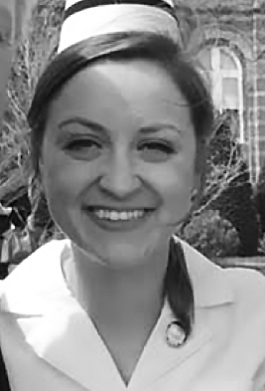
My Life with Congenital
Heart Disease
As a child growing up with CHD, Abigail Wintersteen, RN spent a lot of time at Boston Children’s. She developed a passion for medicine, and committed herself to helping patients whose experiences she understands so well. She recently graduated with a license in nursing, and is now a cardiology nurse in Vermont.
I decided that if I couldn't play sports, I was just going to be the best student I could be, and I went from getting decent grades to getting a lot better grades. I channeled all my energy into that…I'm now a cardiology nurse. I like to think that my past history has some meaning in my life.

Full disclosure: My mom had to tell me my own heart story, since I was pretty young when it all happened. So, we’ll see how this goes.
I was born as the third child of my parents. I've got an older brother named Alex, and an older sister named Caroline. They're the best. I was born healthy, or at least that’s what we thought. My mom says that I was kind of fussy, and not really eating very well at the beginning. She kept bringing me in to my doctor, and was like, "Something's wrong. Something's wrong." And they just said, "She's just a fussy baby." My mom's reply was, "I HAD a fussy baby,” referring to my older brother, “And this isn't a fussy baby.”
And then my mom finally just took me to my pediatrician and she said, "I'm not leaving here until you tell me what's wrong with my daughter." They did a full physical exam on me. The doctor was ready to walk out the door, saying, "Just a fussy baby," when my mom said, "You didn't listen to her heart." The doctor said, "Oh, yeah." She went to listen to my heart and said, "I'll be right back. I'm going to grab someone else." So another doctor came in and said, "I think you need to go talk to a cardiologist."
So then my mom, the brave woman that she is, took me to the cardiologist and that's where we met my doctor, Dr. Drucker. Dr. Drucker said, "Your baby's very sick. You need to be admitted to the hospital." I had cardiomyopathy. They stabilized me, and I went down to Boston Children's Hospital, where I was diagnosed with ALCAPA, anomalous left coronary artery from the pulmonary artery.
I went through my first surgery when I was three months old. I don’t remember it. My mom said I was in the hospital for awhile. The surgeons went in and simply, (well, not SO simply) put my artery into the aorta where it was supposed to go. After the surgery, I wouldn't come off of bypass, so they had to put me on an LVAD, which is old-school, and they said that I had 72 hours from that transition to get off the LVAD. They tried to wean me off of it once, but it was unsuccessful. And then they took me down again to try to wean me off of it. My mom and dad were in the waiting room and my mom saw my doctor pretty shortly after they started weaning and she thought, "Oh, no. That was too fast." But he came down the halls and she said that he was skipping, and he pounded the air and was like, "She's off! She's off!" But even once I was off, I was still in the hospital for a really long time, still on the ventilator. And then I developed a blood infection. I was septic and fought that. And then I went home with my parents.
Then again at two and a half years old, I needed some help with my mitral valve. I went into surgery again. I still don't remember it. The surgeons went in, and fixed my mitral valve regurgitation. I was in and out of the hospital in four days, much faster than the first time. It was back to life as usual, getting picked on by my siblings. Then, at four, I had to go back for another mitral valve repair. That one I remember, kind of. I remember coloring. I remember being pulled in the wagon in Boston Children's. They are all good memories. During that surgery, they put a titanium ring around my valve, and they were able to put a larger one in so I could grow into it. After my third surgery, I was a pretty normal kid. I played hockey, lacrosse, field hockey. It all was going smoothly.
And then when I was a sophomore in high school, I developed a-fib. I had all the good stuff that led to that: the enlarged left atrium, mitral valve regurgitation, and a lot of scar tissue. When I went in for the first time, they just cardioverted me, but it kept happening. I think I got cardioverted about 15 times in one year. And then I was put on Coumadin. Joy. That's when the sports stopped. This was sophomore year of high school. It was a pretty hard time because I went from being a very active teenager, to a very pissed-off teenager. I tried not to get negative, but I tended to have those times. I decided that if I couldn't play sports, I was just going to be the best student I could be, and I went from getting decent grades to getting a lot better grades. I channeled all my energy into that, and I got accepted to Saint Anselm College in Manchester, New Hampshire, for nursing. I went to school.
And then going into sophomore year of college, I was having a lot more episodes of a-fib. The doctors were again worried about my valve. The summer after my freshman year I went back to Boston Children's for my fourth and most recent surgery. My two best friends, Emily and Rebecca, came to visit me. Bex is the blonde, and Em's the ginger. We are kind of inseparable. We live together right now. They came and they brought me a sign. They also brought me a stuffed pig because I had a pig valve. The bacon jokes haven't stopped. That surgery, I was in on Monday and I was out Sunday. I was very determined.
I remember everything, pretty much, from that surgery. I remember the chest tubes getting pulled out: very painful. They have an internal pacer lead that's on your stomach. I remember them pulling that out and it just feeling like a thread woven through my body. But again, I like to think of myself as a strong person, so I made it through that and then went back to school. Recently, my parents came to my pinning ceremony when I became a nurse. At school, we have the option to dress like old-fashioned nurses and we all do that. The dresses go down to our ankles.
Nowadays, I graduated from Saint A's. I was the last one to graduate as my last name is Wintersteen, and the nurses are the last ones to graduate. I got a job at the UVM Medical Center. I'm a cardiology nurse. I like to think that my past history has some meaning in my life. So, I like to pass that on to my patients. I don't bring it up with everybody, but if some of my patients are having an extremely hard time, I like to tell them that, "Hey, I can relate. It gets better. Just keep pushing through."
But I am very happy. I'm living with my two best friends, Em and Bex. We live in an apartment in South Burlington. We're having a great time. I don't know what's in the future, but I'm excited for it. I just want to give a major thank you to my mom. She’s the best. And to all of the parents, pretty much just keep doing what you're doing. You're doing the steps, you’re here, and we do appreciate it. Thanks.

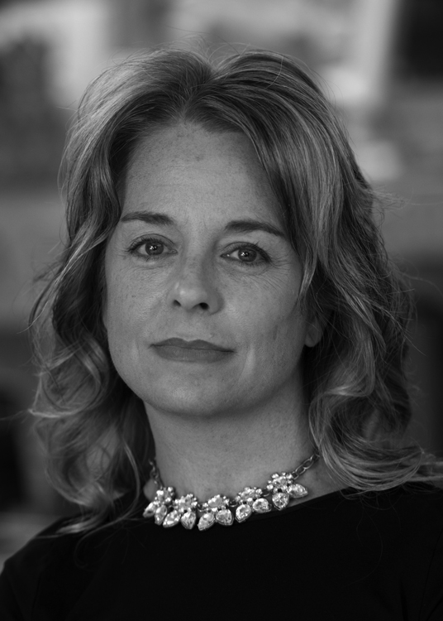
Avery’s Journey
with CHD
As the Director of Nursing Patient Services in the Neonatal Intensive Care Unit at Boston Children’s, Cheryl Toole, MD, RN, CCRN, has a lifetime of experience caring for vulnerable babies. But she gained a new perspective of the experience when her own daughter was born with hypoplastic left heart syndrome, and she now is able to share Avery’s story with other parents.

On April 21st, 2004, life as we knew it was perfect. It was as perfect as it could ever be, welcoming our first and only child, Avery, into the world. We took our first picture as parents and as a family, not having any idea what was about to follow. Two hours later, the pediatrician heard a heart murmur. Four hours later, we were told that she might have ventricular septal defect, which sometimes might mean a surgery. And six hours later we were told she had hypoplastic left heart syndrome, which is basically a terminal congenital heart defect without a series of three staged surgeries. Life as we knew it seemed like it was over, our dreams were shattered, and what we had imagined and hoped for had changed forever. We were left to repair not just one broken heart, but three.
CHD is invisible for many of our children, so it’s crucially important for us to advocate for their needs. On the outside, they might look exactly the same, but they definitely do have different needs.

Four days later, we put on our brave faces as our parents came to greet their grandchild for the first time. Avery had her first surgery, the Norwood, when she was five days old. We went home for the first time the day before Mother's Day, and that was one of many gifts to come as the mom of a baby with CHD.
For months, we struggled with feeding Avery, and with growing her. We used industrial calorie formula. We had to wake her up to eat, setting our alarm at night to go off every three hours. We did not have a baby that would cry and wake up on her own because most kids with CHD don't have enough energy to do that. So, when I hear moms complaining about their crying baby at night, it's a little bit hard to see that as a nuisance. That would have been music to my ears.
Even as a NICU nurse, I can feed basically anything, but I found feeding Avery to be extraordinarily difficult. To not be able to feed my own child was paralyzing to me. My husband, Mike, and I did eventually succeed. With a lot of effort, we got her to gain enough weight for her bidirectional Glenn.
Between 2 and 4 years of age, Avery had four more open heart surgeries. She was one of the lucky kids with HLHS with a borderline left ventricle, so the hope was to reconstruct her heart back to a two-ventricle circulation. Her valves, however, were her biggest problem, so she ended up with two aortic valve replacements, a BT shunt with fenestration, and multiple mitral valvuloplasties. For several months when Avery was four, life was normal, or at least our normal, and Avery was thriving. She was the picture of health. She loved going to the beach. She has always been the leader of our family. She's a take-charge, pull-it-together, mom-and-dad type of girl.
In December of 2008, it was time for Avery’s biventricular repair, another major turning point. Avery, unfortunately, did not tolerate it as expected, and, unlike all her other surgeries, which she came through with flying colors, this time was different. She came out of the OR on ECMO, which is a heart lung bypass machine, because they couldn't transition her off the cardiopulmonary bypass pump. Our hearts, again, were broken in half.
But Avery is a warrior, and she fought and she slowly recovered. The ECMO circuit in the ICU, along with many doctors and nurses, were able to save her life. However, when we were getting ready for discharge, Avery went into cardiac arrest. She was placed on ECMO for a second time. She again recovered, but her heart continued to struggle. Ultimately, she ended up having two more cardiac arrests, which resulted in another two ECMO cannulizations.
In June of 2009, Avery was placed on the Berlin Heart, which was not FDA-approved at the time. She was dying. And she was placed on a waiting list to receive the only thing that could save her: a new heart. 52 days after she was placed on the list, Avery received the heart of a little boy, 8-year-old Dalton. Dalton was a perfectly healthy child who had a seemingly carefree and limitless life ahead of him, until he was tragically hit by a truck while he was riding his bike. His parents made the selfless and inexplicable decision to give their son's heart to Avery. Life, again, changed forever, this time for two families.
Ultimately, Avery had nine open-heart surgeries, eight of which required cardiopulmonary bypass, all of which required cardioplegia, which is stopping her heart. She had four emergent resuscitations to ECMO. These treatments were life-saving. But what do we do after? We really need to focus on making sure these children thrive. When Avery was listed for her transplant, her cardiologist said, "We don't transplant any child who might need a new heart. We transplant children who, we feel, will have the ability to thrive and have a quality life."
Avery was 100% sensitized to her donor, which meant her body saw her new heart as a very dangerous invader. She created many antibodies to try to protect her body from this intruder. She was at the highest risk of rejection, and required months of rehabilitation. She went home on 28 different medications.
Avery recovered, and, after about a year of hospitalization, she went home. We still don't know why we were chosen as the lucky ones, to have this positive outcome. We went to Capitol Hill to advocate for improving healthcare for all children, and to improve graduate medical education. CHD is invisible for many of these children, so it’s crucially important for us to advocate for their needs. On the outside, they might look exactly the same, but they definitely do have different needs.
Avery plays basketball, soccer and lacrosse. She dances, and she texts, a LOT. Avery loves spending time with her friends. If you saw Avery with her friends, you would never be able to tell which girl had this story. I recently dropped Avery off for a week of Heart Camp in the Berkshires. Avery is not just surviving, she is truly thriving beyond what we could have imagined. She is perfectly herself, and we would not trade one day of her life, or herself, for any other child.

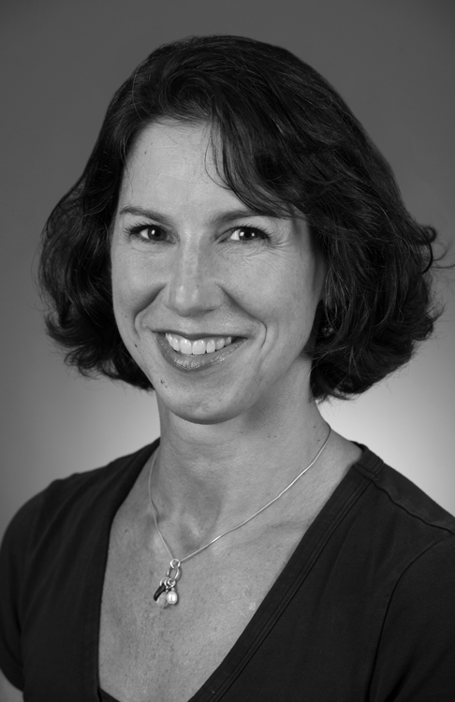
Recreation and Community for the Child
with CHD: Refocusing on the Positive
Naomi Gauthier, MD, is the director of the Cardiac Fitness Program at Boston Children’s and an instructor of Pediatrics at Harvard Medical School. She also runs Camp Meridian, an overnight camp for children with CHD in the White Mountains of New Hampshire.

Refocusing on Thriving
In my career so far, I have seen the field of congenital cardiology go from being unable to offer any therapies, to the expectation that our children will survive. Given this extraordinary development, the question now has to turn to whether children with CHD are optimally thriving. As is well known, children with CHD are vulnerable in social, academic, emotional, and physical realms, and they experience an increased rate of neurocognitive and behavioral disorders. These vulnerabilities have historically translated into lower career achievement, higher rates of depression and anxiety, lower rates of marriage, lower rates of physical activity, and increased rates of obesity. We cannot trade one problem for another. Rather than remain stuck in the looming negatives, we need to refocus on hope and optimism and positivity, and how we can look forward.
Children with CHD are surviving, but it is not clear if we are optimally helping them to thrive. There's an enormous amount of recreational opportunities out there, and we need to think about how to access these resources, and how to recommend them to children. We should also find ways to change messaging about CHD to the positive. If we can set the bar high, then the children will rise to meet it.
My question is how all of us touched by people with congenital heart conditions can help take surviving, and turn it into thriving. I think part of the answer to this question lies with the medical establishment partnering with the community, and rethinking the role of the medical team and how we define “medical intervention.” One way or another, most people are comfortable with medical and surgical care being an “intervention.” Increasingly, people are getting comfortable with considering the work of the cardiac neurodevelopment field as a medical intervention. However, there is still substantial room for growth in our understanding of what constitutes a medical intervention within the community.

Camp as a Medical Intervention
I think the best example of a community intervention that can be understood in medical terms is disease specific camp. Disease specific camps have been around for decades, and have been described as transformative experiences for children around the globe. The positive effects of disease-specific camps, including CHD-specific camps, have been demonstrated in research. A 2006 study from Belgium looked at 25 kids with congenital heart disease who went to a three-day sports camp. In that time, the campers saw significant improvement in physical functioning, general health, self-esteem, mental health, and overall behavior. What other therapy has that much success in such a short period of time? In a follow-up study, researchers found these effects persisted for physical and emotional functioning three months later.
I have long thought about what it is about such camps that can bring out such hope and resilience in kids. How can we find the salient elements of effective camps and distill them? In 2013, a research group interviewed 13 kids with congenital heart disease attending a one-weekend camp. Although it was only two days, the positive impact on campers was strong. During interviews, campers identified three important elements of the camp experience that they thought contributed to its power and success. The first element was feeling accepted, and developing supportive relationships with peers and counselors. This finding is not surprising, because a sense of belonging is a common desire, and it is powerful when found. The next element was experiencing fun and learning. This finding is interesting, because the children themselves recognized that having fun was important, but not just fun in and of itself: it was fun associated with, and intimately tied to, learning. Lastly, the children identified experiencing the freedom of the outdoors in a natural environment as an important element of the camp experience. Freedom in the outdoors was important for two reasons. First, these children recognized something that has been established through research in the adult world, demonstrating that connecting with nature changes our stress hormones, all the way down to the chromosome level, and allows us to deal with stress better. The second reason is that the campers focused on the word, “freedom,” which implies that the children found the experience of stepping out of their bounds safely and effectively to be empowering and freeing.
For those who may not have witnessed such a camp, it is a struggle to explain just how impactful these experiences are. I have had the great fortune to be able to run a camp for kids with congenital heart disease for the past 15 years. Every year it is just one of the most jaw dropping experiences, not only as a physician and a cardiologist, but also as a mother and a human being. We made a 2015 video called “True Hearts Revealed” about Camp Meridian, and this is the story of one of the campers in the video, in his own words: “They [the counselors and other campers] are just so happy to see me. They named me Tiny…[Climbing the rock wall] was so hard because I was like, ‘Should I go on? Should I stop?’ When everybody cheered, ‘You can do it!’ I was just like an inch away from the top. I'm like, ‘I can do this,’ and I hung on. I just was so happy when I got to the top because last year I got to the middle. Then this year I finished it off. I'm very excited about that.” Another child summarized her experience at camp this way: “Once you get here, you’re immediately going to make friends. You’re immediately going to feel bonds, and not just the bonds that we have physically with our condition, bonds just like any other friends you would make. It’s the best experience in the world.”

Ring in the Hand Moments
Watching these kids at camp every year has driven me to ask how we extract this really powerful experience, and put it into every healthcare encounter, because not every kid is going to be able to go to camp. I have a little story that I think of often when I contemplate how to break down the pieces of this experience in order to try to replicate them in tiny bits in the health care setting. This story is personal, regarding one of my sons when he was about eight years old. He had become afraid of going into water over his head. He already knew how to swim, so this came out of nowhere. I took him back to his swim teacher. The two of them went to her pool, and after a short conversation, she threw some rings in the deep end and gestured for him to dive in. Incredibly, he turned around, dove to the bottom, picked up a ring, and then broke the surface of the water, holding that ring aloft, and grinning. To me, that was it: a “ring in the hand moment” when
you were not sure if you can do something, and then you have tangible evidence in your hand that indeed, undeniably, you succeeded. And for such a moment to occur, three things have to happen: 1) someone credible and trustworthy has to have confidence in you, 2) that person needs to provide a carefully-designed way for you to face a challenge, and 3) the belief they have in you, combined with a controlled situation in which to test yourself, translates into enough of a belief in the situation to allow you to try. And when you try, and in some fashion succeed and stand there holding that ring in your hand, you cannot help but translate that to an internal message, and to find that power within yourself. That message can then be taken anywhere, and applied to facing other challenges in many aspects of our lives.

Teaching “I Can” in the Medical Setting
How do we transfer that experience to the health care setting? I think that establishing positive expectations is one. In order to allow children to feel and then experience “I can,” healthcare providers need to empower patients to participate with very intentional messaging. Participation and “I can” moments usually do not just happen without intentional guiding and planning. One piece of the intentional guiding is the promotion of a growth mindset. Many in education are well aware of a spectrum of internal thought processes that range from fixed mindset through to growth mindset. Moving toward a growth mindset involves approaching challenges as a chance to improve, and to work toward continuous improvement, rather than feeling that everything is an obstacle. There are wonderful programs that are being adopted in schools all over that work on fostering a growth mindset. Even simple factors can promote growth mindset development, factors as simple as body language, words, and messages. Healthcare providers need to recognize these factors, and learn how to harness them properly.

Horses, Rats, and the Power of Expectations
To give some background on the importance of subtle cues, I am going to tell another story that dates back to the turn of the century, about a horse named Clever Hans. Clever Hans lived in Germany and was taught to do incredible math feats. He was taught how to count. He was taught how to add. He was taught actually pretty sophisticated things like, "If the second Thursday of the month is the 13th, then what day is the fourth Friday?" He would tap the answers out with his hoof. Hans was paraded around Europe to entertain crowds, and eventually caught the attention of a scientific council that was brought in to investigate his skills. At first, everyone thought that Hans’s performance must be a hoax. So, the first thing the scientists did was to take the trainer away, and replace him with a researcher. But even when a researcher was asking the questions, Hans was still able to answer correctly. Eventually, however, after experimenting, the researchers learned that Hans could only get the questions right if the person asking the question knew the answer. and if Hans could see the questioner. It became clear that Hans was not really performing math, instead he was reading he questioner’s body language. Paying attention to the subtle cues of facial expression, body language, and word intonation, he could discern when he was getting close to the right answer, and when he should stop tapping. Instead of math skill, Hans had an acute ability to read the silent cues humans were sending him, and he adjusted his behavior to please the questioners, and to get a reward.
The story of Hans begs the question: what subtle cues are children with CHD seeing and internalizing every day? What happens when they are on the playground, and the teacher involuntarily lurches to protect them from falling, or looks concerned when they run too fast? Conversely, how high do these children reach when they are encouraged to climb a rock wall with their peers and counselors cheering them on?
Approximately 60 years after the Clever Hans phenomenon, a psychologist named Rob Rosenthal was thinking about this idea of positive expectations, and about how children may be influenced by expectations. His early experiments were on his lab rats. He took his rats and divided them into cages. He identified the cages as two different breeds, one considered “maze dull,” or not very smart and thus not able to learn the experimental maze well, and the other “maze bright.” He then brought his researchers in, and assigned them to run standard maze experiments with one or the other type of rat. The participants found that the “maze bright” rats did much better navigating the mazes, and earned superior scores. However, there was in fact no initial difference between the two groups of rats: all were identical, ordinary lab rats, and Rosenthal had misled the participants in telling them that the rats were actually different breeds. He concluded that the two groups of rats performed differently in the mazes because of the expectations of the researchers, which led them to handle the rats in subtly distinct ways. Dr. Rosenthal then studied the effect of differences in expectations in elementary school children. At the beginning of the school year, he reported that he gave students two tests: an intelligence test, and an aptitude test. The aptitude test, he told the teachers, had identified a subgroup of students who, regardless of their starting intelligence, were going to “spurt” or really blossom during the school year. He then came back at the end of the school year and retested the students, and found that there was a tremendous difference in intelligence gain in those identified as “spurters.” But again, as with the lab rats, the children had been randomly assigned to the two groups, and had never been administered an aptitude test. Just as with the rats, the differences in student achievement were attributed to subconscious behavior in the teachers, who set higher expectations and provided encouraging cues to the children who had been labeled “spurters,” and that this subtle encouragement allowed the “spurters” to believe in themselves, and to rise. I think that in the healthcare system, we need to consider the lessons of this research. We need to determine how to talk to, and interact with, children with CHD, so that we can encourage them to grow and succeed.

Helping Children to Rise
How do we maximize the positive input received by children with CHD? How do we harness the knowledge from the education and the recreation communities, and get our patients and children to rise? What do we know about recreation, particularly camp experiences, that allows a child’s best self to emerge? The answers are not yet clear, but at the very least, we need to start thinking about our language and our silent interactions, and to strive to bring out the positive. There do exist many recreational programs in the community that can provide good messaging, as well as opportunities for kids to try new things, and to find their “ring in the hand moment.” So, while we in healthcare take time to carefully research which elements of recreation will make a difference, and how to deliver those messages, we must also increase awareness of, and involvement in, existing community programs and recreation. Out of curiosity, I did a quick Google search and, in .0026 seconds pages and pages of options for kids with CHD and/or special health care needs were displayed. These results included opportunities like golf, kayaking, rowing, adaptive cycling, karate, swimming, horseback riding, adaptive rock climbing, theater, cooking, and music classes over at Berklee. There was even an overnight dorm experience for teens transitioning to adult care.
There's an enormous amount of recreational opportunities out there, and we need to think about how to access these resources, and how to recommend them to children. In 2013, Karen Uzark from Michigan described a clinic model that was effective and manageable. Children were screened for broad needs when they came for their regular clinic visits, their most problematic domains were quickly identified, and then clinicians offered a list of solutions within the visit. The medical team found that this procedure was useful to patients, fit well in to the clinic workflow, and made a difference in the health care setting. Efforts like Dr. Uzark’s represent a huge start, although we have a very long way to go to make recreational opportunities a universal part of our healthcare encounters, and to ensure that both verbal and nonverbal language are sending the right message.
In summary, our children with CHD are surviving, but it is not clear if we are optimally helping them to thrive. We know their vulnerabilities, and we also know that kids are going to pick up on many cues, just like Hans did. We must carefully consider whether our cues are setting positive expectations. If we can set the bar high, then the children will rise to meet it. We must ask ourselves: what “interventions” will get them there? As a start, clinicians must recognize that the community recreation and camp programs in place are types of “medical interventions” that influence medical outcomes, and we should become advocates to encourage kids to participate. We should also begin to find ways to model positive behaviors, and to change messaging to the positive; for instance, instead of referring to heart “defects,” which makes a child sound defective from the start, we can adopt the term “conditions,” which is less judgmental, and which leaves more room for a positive interpretation. The list of subtle cues and recommended changes may be long, and the access to community programs may be limited, and short in duration. There may be limited outcome measures to date of whether a child is “thriving” in terms of whether are rising to their optimal level, like Rosenthal’s students, or somehow held to lower expectations. But the return on the investment of effort and time to figure out how to promote thriving could reach enormously high, transformative levels. We need all stakeholders: parents, healthcare providers, educators, and other people in the community, to work together to harness the power of the positive to be able to move forward.

My Experience with
Heart Transplant
Gregory Wang is a student at Bryant University, and the recipient of a heart transplant. Gregory shared his story at the symposium, which was his second heart anniversary, after finishing his first year in college. His whole family was in the audience, cheering him on.
As a junior in high school, we learned my heart was failing and I needed a transplant. I knew the right heart would come along some day. Through my whole senior year, I was just pushing myself. I have a good work ethic, a never-give-up kind of thing. Now I attend Bryant University and I’m in their honors program.

A Thanksgiving ER Visit
It was the night before Thanksgiving, 2014. I was a junior in high school, and for several days I had been coughing, and just didn’t feel like myself. But then for a whole day I just didn't leave the couch. I told my mom I think I feel all right, but we gave a call to the local pediatrician office anyway. The nurse said to just go to the local emergency room, so that's what we did. On the way to the hospital I asked my mom, "Do you ever feel palpitations in your heart? Like, constantly?" She answered, "Yes, like maybe after like a hard workout," but mine were certainly different. Mine were constant.
I finally went to the emergency room at Lawrence General Hospital. In the ER, the nurses brought me in and raised their stethoscope to my chest, and they knew instantly that my heart was wrong. This was bad. We went to get an EKG, and the EKG read 200 fibrillations or more at times. Clearly my heart was in a bad state. I was transferred to Boston Children's Hospital at midnight of Thanksgiving morning, and my life changed forever.
Early morning on Thanksgiving, I ended up in the Cardiac Intensive Care Unit (CICU). It turned out my heart was severely enlarged, and there was a big blood clot in my left ventricle. The doctors put me on a drug called Heparin in the hope of breaking the blood clot up. This was a big scare for my family, but we felt relief when after one day, the blood clot disappeared.

Preparing for Transplant
Within a week, however, there was more drama, as we learned my heart was failing and I needed a transplant. My family was in complete shock. This meant more time in the CICU. That didn't quite faze me though. I'm a laid-back person, so I just took it step by step, and just took it in, and tried to go on from there. A couple days later, we get our genetic test back, and I found I had a mutation of the LAMP2 gene, which is a protein gene. This mutation is associated with Danon disease, which is a very rare disease, and there isn't much information out there about it.
To prepare for the transplant I had a special diet, and the restrictions were hard, especially for someone who loves food. I was specifically restricted around salt and liquid, because there was about 20 pounds of water in me around my heart, which was incredible. After two weeks in the CICU, I was finally off oxygen support, and was able to get to know my nurses and doctors. In December, I needed a defibrillator/pacemaker implanted. Then I had to get stronger physically and mentally before being discharged. But I knew I was my old self when I could make the nurses laugh, and I had a special bond with each and every one of them.

Waiting for a Heart
I was released a couple of weeks before Christmas, and was officially on the transplant list. Sitting back on my couch at home was the nicest thing in the whole world. Facing a table of medications, however, made me realize that my life had drastically changed.
After the Christmas break, I returned to school, but there were many ups and downs. I had weekly hospital visits, and was hospitalized three more times, with two ten-day hospital stays, and two atrial fibrillation mishaps. The third hospitalization was in May to take care of the repeated A-Fib. After the incidents of med complication and dehydration, the doctors discharged me with a PICC, so I could be on Milrinone all the time. This bumped me up to the Heart Transplant waitlist A.
I couldn't go back to school after that. I had to get a lot of in-home tutoring, which was fun in a way, but not really. It tired me out because my energy wasn't that great. I worked on finishing just one course all spring and summer.
The First Call
Toward the end of that school year, in June, we got our first heart call. We were on the way to a clinic, and my mother's phone rang. When she realized the call was to let us know that a heart was available, she raced to the hospital. We got settled in, and did all the testing and pre-op preparations, but the time of the procedure kept get moved forward. They just kept giving us new times. By midnight of that night, they called it off. My doctor said that the heart was not right for me. My mom was devastated. But again, I wasn’t really fazed. I knew the right heart would come along some day. The next morning, I went onto my phone and I searched egg roll recipes. I asked my mom, "Can we go to Market Basket, or go to the food shop to get the ingredients?" Typically, we don't eat fried food, but after a case like this she was like, "Why not?" So we made egg rolls.

The Second Call
After that mishap I was still on Milrinone. I still had to do home tutoring, to catch up with my work. Then on July 22, 2015, we got another call from Dr. Singh. This time Dr. Singh said that they were sure this heart would be perfect for me. I had to go through the same long process of tests, but this time I wasn’t as scared or afraid, since I had already gone through it the first time. I also could not eat or drink, and that was horrendously hard. However, this time the doctors kept saying that everything was good.
When I woke up after my seven-hour transplant surgery, I was in the CICU hooked up to multiple machines. I had three tubes in my upper stomach, and an uncomfortable intravenous line in my neck. There was also a complication when my lungs collapsed, but I recovered with no problems, and right away I had more energy. Soon I was up and about, talking and joking with the staff. I was in the CICU for four days,
and they released me after only twelve days. I learned it was one of the fastest heart transplant recoveries ever at the hospital.

Recovering from Transplant
When I got home from the hospital, I got still more tutoring to get me caught back up and back into my mode. For the first three months after the transplant, I wasn’t supposed to go out much because of the bacteria, and when I went out, I had to wear a mask. I endured that for three months. I realized that, moving forward, now I have this new life that consists of taking regular medications, and regulating my heart.
I went back to school October 13 2015: Columbus Day. I missed a good month of school at the beginning of that year. Even when I was back at school, I still had to play catch-up with all my classes, which was certainly one of the hardest things, especially for my honors courses. As Thanksgiving came around again that next year, I looked back and I realized that I was lucky to live near one of the best hospitals in the world. The hospital staff, especially the nurses, always made the feel like home, making jokes and laughing. The doctors not only have great knowledge and skills, but also have remarkable human qualities.
Through my whole senior year, I was just pushing myself. There really wasn’t anything else for me to do. I have a good work ethic, a never-give-up kind of thing. Even if something is my weakness, I still go at it and try. I graduated that year, in the spring of 2016. I ended up with a 3.6 GPA as well as a National Honor Society, and I graduated with honors, which was something I was very proud of.
I decided not to take a gap year, even though I was offered one, and now I attend Bryant University. I'm in their honors program, which is challenging. Two of my strengths are time management and organization, which has been very helpful at college. I basically mapped out my days of what I'm going to do, how I'm going to get it done, and I always make sure not do my work the night before it’s due.
College is certainly challenging. It is fun with all the free time that I have, with all the new friends that I made, and ultimately the academics. Now I’m going into my sophomore year, so this coming fall in September, all I can do is grow. All I have to do is grow, thrive, and work my hardest to get the grades that I want. Thinking back to my experience over the last two years, I am thankful that my family was always by my side. My relatives kept me in their prayers, and my mother's devotion to my recovery made me more grateful for what I have. I am now much more health-conscious than before. I realize that life is unpredictable, but that I can overcome any challenges that come my way.

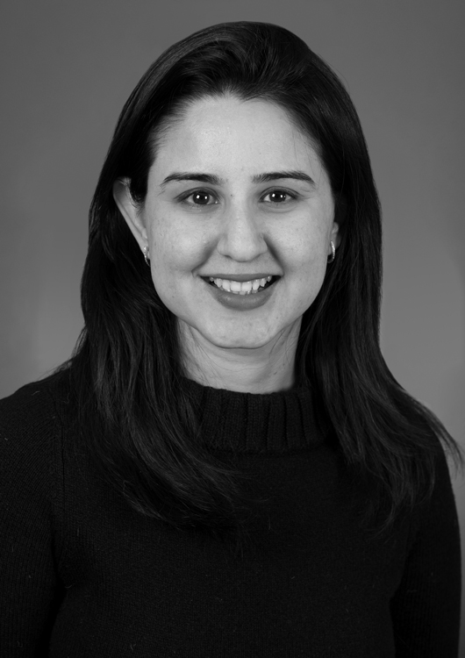
Concerns and Recommendations
for Young Children with CHD
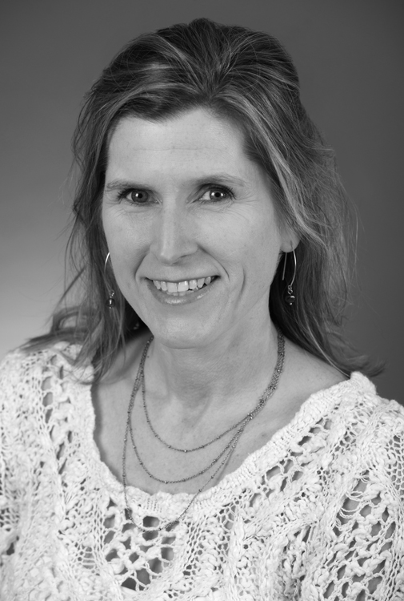
As staff psychologists in the Cardiac Neurodevelopmental Program at Boston Children’s, doctors Anjali Sadhwani, PhD, and Samantha Butler, PhD, provide direct care to most of the young children with CHD who come through the hospital. Dr. Sadhwani evaluates toddlers and preschoolers who are returning for follow-up, and helps families to understand their children’s development, and to connect with appropriate services. Working in the inpatient floor, Dr. Butler assesses new babies and returning patients and helps families to work on developmental goals from the beginning of their children’s lives.

Many children with CHD experience delays in their development, which are noted as early as the newborn period, and which continue into school age and adulthood. Infants with CHD show early challenges in motoric, oral, attention, and autonomic systems, which contribute to their ongoing challenges in feeding, attention, motor skills, autonomic regulation, behavior and cognitive skills. Many adolescents and adults with CHD show deficits in their intellectual, language, memory, attention, social and emotional functioning which lead to concerns in school and social life. Given the known long-term risk of neurodevelopmental challenges for children with CHD, the American Heart Association recommends regular surveillance, screening, evaluation, and reevaluation of neurodevelopment in the pediatric CHD population. We will review the common developmental concerns and challenges for children under 3 years of age with CHD, and discuss therapeutic options and recommendations for families and providers.
Magnetic resonance imaging studies have shown that brain development and metabolism are affected in utero among infants with some forms of critical CHD, and brain maturation at birth is delayed by about one month compared to typical newborns. As a result, infants with CHD are often similar to pre-term infants in their high risk of cognitive, language, and motor delays, and their regulation difficulties related to state management, feeding, and
sleeping.

Common Concerns and Challenges
Area | Main Challenges | Recommendations
Gross Motor | Trouble with head control; difficulty with tummy time; poor balance and coordination; delayed gross motor skills. | Hold in prone position to practice tummy time; Practice slow rolling; Ball play (rolling, throwing, kicking); Play on the playground.
Fine Motor | Difficulty with opening hand; extending thumb; pincer grasp; asymmetrical use | Offer objects to feel with hand and fingers; Present objects at midline; Build/stack blocks; Use Play-Doh, clay, and sand.
Social | Attachment; eye contact; lack of responsivity; limited facial expressions and imitation. | Provide soothing and reduced stimulation if needed; Talk, read, or sing to your child all the time; participate in play groups.
Language | Hearing loss; poor oral-motor coordination; delayed use of single words/word approximations. | Imitate your baby’s cooing & facial expressions; Use speech that is clear and simple for your child to copy; Read to the infant; Sing simple songs/ nursery rhymes
Cognitive | Limited energy; limited exploration; decreased reaction to environment; difficulty with problem solving. | Provide toys to feel and explore; Use mirrors; Hide toys and help find them; Play imitation games; Reduce screen time.
Behavior | Hyperactivity and inattention; unable to calm self, behavior challenges: hitting, biting, throwing; inability to focus. | Use visual schedules; Use positive discipline strategies; Use praise to promote positive behaviors; ignore and time-outs for unwanted behaviors.
Nutrition & Feeding | Lowered height and weight; slow growth; need extra calories; tire quickly; reflux; allergies; gagging or choking behaviors; aspiration. | Provide high-calorie diet (milk, formula, or breast milk); Supplemental tube feedings; Create consistent schedule; Feeding/Mealtimes should be positive; Oral muscle activities with straws, bubbles.
Sleeping | Trouble falling/staying asleep; waking up several times at night; not able to sleep in own bed. | Establish a firm and consistent nighttime routine; Help to self soothe: encourage use of comfort toys/loveys; Use a sound machine; Avoid screen time around bedtime.
Preparing for  another surgery | Significant anxiety around hospitals/clinics and medical professionals. | Encourage medical play; Develop social stories for medical checkups and procedures; Reading children’s books related medical procedures
Parent  Coping | Chronic stress contributes to adult health problems; Symptoms of concern: avoiding, restlessness, fatigue, irritability, worry, angry outbursts and guilt. | Basic self-care: eating healthy, regular meals, sleeping well, taking time for oneself; Connect with other parents of children with CHD; Connect with regional and national support group; Talking to a trained mental health professional.

Resources to Promote Development
1-2-3 Magic, by Tom Phelan, Ph.D.
Discipline the Brazelton Way, by T. Berry Brazelton, MD, and Joshua MD
Feeding Your Baby: The Brazelton Way, by T. Berry Brazelton and J. Sparrow
It Takes Two to Talk, by Ayala Manolson
Just Take a Bite: Easy Effective Answers to Food Aversions and Eating Challenges, by Lori Ernsperger
Sleep: The Brazelton Way, by T. Berry Brazelton
Sleeping Like a Baby: A Sensitive and Sensible Approach to Solving Your Child’s Sleep Problems, by Avi Sadeh
Sleeping Through the Night: How Infants, Toddlers and Their Parents Can Get a Good Night’s Sleep, by Jodi A. Mindell
The Incredible Years, by Caroline Webster-Stratton, Ph.D.
The New Language of Toys, by Sue Schwartz
Touchpoints-Birth to Three Revised Edition, by T. Berry Brazelton and Joshua D. Sparrow.

Early Intervention
Some children with CHD will need therapeutic services such as physical, occupational and speech therapy. Parents of children < 3 years of age are encouraged to contact their community based Early Intervention (EI) program to evaluate their child’s need for services. EI is a preventive model of caregiving. As a country-wide, developmental service, they provide services for children at risk for delays.
Types of interventions include:

- Physical Therapy
- Occupational Therapy
- Feeding Therapy + Nutrition
- Parent Support
- Speech & Language Therapy
- Developmental Education
- Nursing
- Developmental Play Group

All children under 3 years of age that have been admitted to the CICU for cardiac care should be evaluated by EI, even if not showing a developmental delay.
More information on EI in MA can be found at:

Early Intervention: Family Rights
http://www.mass.gov/eohhs/gov/departments/dph/programs/family-health

/early-intervention/family-info/

Federation for children with Special Needs: http://fcsn.org
Parent’s Guide to Special Education: http://fcsn.org/parents-guide

Mass Gov: Best Practices in Early Childhood Transition
http://www.mass.gov/edu/docs/eec/2014/20140515-early-childhood-transition-english.pdf

Family Ties
https://www.massfamilyties.org/

Conclusion
Children with CHD often show delays in their motor, cognitive, communication, social, and regulation skills which can lead to challenges in their learning, and lead to long-term delays and disabilities in adolescence and adulthood. Children with CHD should be followed routinely by a neurodevelopmental program that provides ongoing developmental assessment and recommendations to support development.
In addition, it is important to begin developmental therapy as early as possible for children with CHD. Therapy should begin in the newborn period with inpatient based developmental services such as PT, OT, Feeding and Speech, and should continue at home with EI services. Families and caregivers at home should be aware of common developmental concerns for children with CHD, and basic intervention techniques. This article outlined specific concerns in gross motor, fine motor, social, emotional language, behavior, nutrition, feeding, and sleeping skills along with needed support for preparing for surgery and parent coping. We suggested ideas for intervention to enhance development. We believe that with early identification and intervention children with CHD can show improved developmental progress.

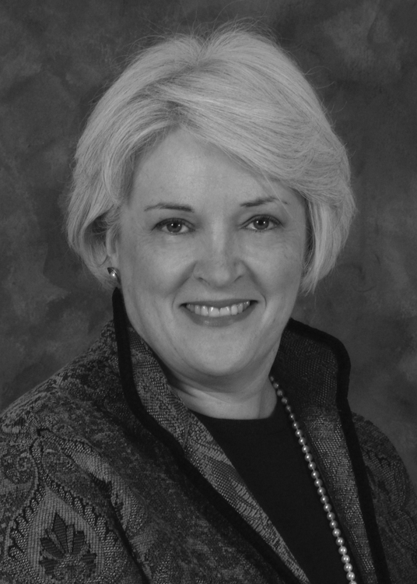
Cardiac Neurodevelopment:
When to Intervene
Janice Ware, PhD, is the Director of the Cardiac Neurodevelopmental Program and a Senior Psychologist in the Developmental Medicine Center at Boston Children’s, as well as an Assistant Professor of Psychiatry and Pediatrics at Harvard Medical School. She helped to found Boston’s landmark Cardiac Neurodevelopmental Program, and is a national leader in the field. As a psychologist, Dr. Ware provides assessment and treatment to children and adolescents with CHD.
Through regular follow-up and appropriate interventions, the challenges associated with CHD can be treated and prevented, and parents can feel confident that they are providing their children with the supports they require to meet their unique needs.

Infant Follow-Up Programs
In the late 1970s, as medical advances allowed for increasing numbers of premature infants to survive, neurodevelopmental follow-up programs were created to monitor the development of surviving children. These follow-up programs resulted in improved neurodevelopmental care and reduced the number of surviving children struggling with developmental delays. The CHD community can learn from this model of care, since as with the premature population in the 1970’s, children born with congenital heart disease are now expected to survive. Given such dramatically improved survival outcomes, the standard of care for children of CHD must move towards a long-term care model. Such a shift towards long-term survival and long-term care has the potential to dramatically improve long-term quality of life for people born with complex CHD.

Challenges Associated with CHD
Children born with complex CHD are at high risk of developing neurodevelopmental delays and disabilities, all of which can be mitigated or even prevented with appropriate and timely intervention. These delays are often apparent in early infancy. At the time of hospital discharge, 81% of babies have gross motor delays, and 69% have fine motor delays, 60% display motor asymmetry, and 37% have difficulty with feeding. These delays exist within a complex family system, and 50% of parents identify feelings of exceptional stress when bringing their babies with CHD home from the hospital. If unaddressed, these early concerns can worsen and compound, leading to further avoidable challenges over the course of development. While all children with CHD are at elevated risk of neurodevelopmental problems, children with certain cardiac conditions are at the highest risk, including those with Hypoplastic Left Heart Syndrome or other Single Ventricle conditions, Tetralogy of Fallot, Transposition of the Great Arteries, or a history of heart transplant. Given these risks, the American Heart Association (AHA) recommends routine neurodevelopmental screening and testing of children with CHD, as well as neurodevelopmental education of patients, their families, and their schools.

Low Awareness of Risks
Despite the strong evidence of high rates of neurodevelopmental delay and disability among children with CHD, misconceptions about these risks are common, and many parents and professionals falsely believe that neurodevelopmental care can be delayed or declined without negative repercussions. Professionals including pediatricians, cardiologists, cardiac surgeons, psychologists, and educators are often unaware of the close association between CHD and neurodevelopmental risk, and may not give parents the information they need in order to monitor and intervene effectively. Parents are often reassured when early assessments are typical, and they may not understand that neurodevelopmental challenges can emerge later in childhood. Many parents are advised to “wait and see” how a child develops, instead of aggressively seeking early evaluation and services. Many children with CHD are found ineligible for Early Intervention services, and some pediatricians advise parents to avoid early assessment, warning that such early measures are not great predictors of later IQ. Such practices can result in a delay in appropriate services, and children’s development can suffer as a result.

Infant Evaluation
Many children with complex CHD demonstrate delays in early infancy, so all children with complex congenital heart disease should be evaluated prior to initial discharge from the hospital. Babies with prolonged initial hospitalizations should be assessed regularly in the hospital, and should have access to goal-oriented, evidence-based intervention services prior to discharge. Infants should return for a follow-up evaluation at approximately age 6-9 months. Severe impairments in neurodevelopmental functioning can usually be identified or ruled out by approximately age 9-12 months, though mild or moderate impairment can still become evident beyond infancy. Whenever risk is identified in infancy, children’s development should be reevaluated between 18 and 24 months.

Following Toddlers and Children
Although infant evaluations are necessary, they are not sufficient. Cognitive testing becomes more reliable as children get older, and assessment is better able to predict adult IQ. By approximately age 18 months, cognitive testing can predict functioning in the preschool years, and intellectual disability can usually be accurately identified by age 6. Many children with CHD experience challenges in school, including problems with attention, reading, and math. School-age children can also struggle with social functioning and anxiety, and their reduced endurance may lead to excessive fatigue and difficulty keeping up with peers. Ongoing neurodevelopmental follow-up is required in order to monitor children’s evolving profiles as they progress through school, and to bring in appropriate interventions and services as they are needed.

Schooling
Families often benefit from expert support in identifying and securing appropriate services for their school-age children with CHD. Many parents are inadequately informed about their and their children’s rights, and the school’s responsibility to provide their child with an appropriate and accessible education. Parents may not be aware of the resources that are available to their children, and so may not know how to ask for them. Some children are placed in classroom settings in which they struggle to learn, such as when a full-inclusion model is used for a child who requires specialized instruction. Students may have inadequate instruction in life and vocational skills, and their grades may be inflated
such that it is difficult for a parent or outsider to determine what, and how much, they are learning. Experts in a neurodevelopmental follow-up program can help families to navigate such challenges, and help ensure that students are making meaningful progress in school.

Transition
Transition to adulthood is an exciting and forward-looking time for families, but also one that is fraught with difficult decisions. Youth with CHD should be evaluated in their teenage years in order to help inform their transition plan and goals. Transition-age evaluations can help identify and fine-tune a young person’s goals, and can ensure that their educational program is poised to allow them to achieve these goals. Evaluators can help youth and their families determine if a college, vocational, or life skills track is most appropriate, and how to pursue the best choice. Young people headed to college should have a good understanding of their own medical and learning profiles, and should be able to advocate effectively for themselves. They should work with their colleges to make sure that any necessary learning accommodations or services are in place before matriculation. When young people are not going to college, they and their families should discuss options for public school between ages 18-22, plus alternative post-secondary placements that are appropriate to their needs and goals. Families planning transition for a youth with substantial impairment may also need to consider topics such as guardianship, driving, and HIPAA agreements before their children turn 18.

Meeting Needs through Prevention
Although the risks facing children with neurodevelopmental impairment due to CHD can be intimidating, there are many resources available to families that can help children to live healthy and fulfilling lives. In additional to the Cardiac Neurodevelopmental Program, local resources include the Center on the Developing Child at Harvard University, the Brazelton Touchpoints Institute of Boston Children’s, and the Learning Disabilities Clinic within Boston Children’s Neurology department. Through regular follow-up and appropriate interventions, the challenges associated with CHD can be treated and prevented, and parents can feel confident that they are providing their children with the supports they require to meet their unique needs.

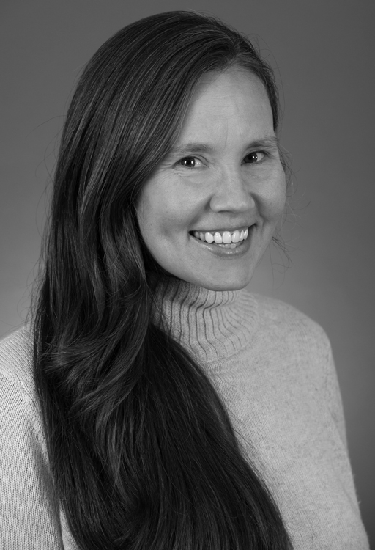
Fear and Anxiety in Children:
What is Problematic and How to Help
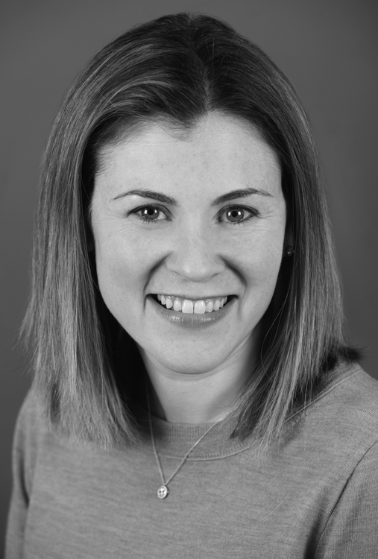
Brandi Henson, PsyD, is a staff psychologist in the Cardiac Neurodevelopmental Program, and a clinical instructor at Harvard Medical School. She works with school-age children through CNP, providing them and their parents with assessment and treatment, and offering classes on topics such as behavior management. As the Clinical Director of Outpatient Psychiatry Services at Boston Children’s and an Associate Professor in Psychiatry at Harvard Medical School, Lauren Mednick, PhD, supports children in coping with challenging medical conditions and procedures.

Anxiety in CHD
Anxiety is defined as a subjective sense of worry, fear, and distress in response to a perceived threat or danger. It can range from a general sense of unease, to a specific fear or phobia. Since anxiety is in response to a perceived threat, it is not always based in reality, and can be irrational, overwhelming, and/or disproportionate to the actual situation. Anxiety includes two components: physical sensations, and thoughts and emotions.
Parents play a critical role in helping children minimize anxiety. They are most effective when they focus on managing anxiety, rather than to avoiding it, and on using coping strategies in stressful situations. Parents should learn to listen and validate a child’s thoughts, without promoting further anxiety.
While all people experience some anxiety, approximately 1 in 10 children meets criteria for an Anxiety Disorder. Rates of anxiety are higher among children and adolescents with Congenital Heart Disease (CHD) than among the general population, and prevalence varies according to diagnosis and age. Children with single ventricle physiology have a five-fold increase in anxiety as compared with healthy controls, and higher rates of anxiety have also been identified among adolescents with Transposition of the Great Arteries and Tetralogy of Fallot. Features of anxiety often persist into adulthood among people with CHD, with 42% of affected adults reporting anxiety symptoms. Children with CHD very commonly report physical symptoms of anxiety, such as dizziness, shortness of breath, rapid heart rate, and headache.

Problematic Anxiety
Anxiety can be conceptualized as existing along a spectrum, with helpful anxiety on one end, and harmful anxiety on the other. All children worry, and some degree of anxiety is normal and necessary at specific times in development. Some worry is adaptive, and can enhance performance in stressful situations. Our fight or flight reaction is intended to allow us to protect ourselves in the face of danger. For example, if a child were crossing a street and a car swerved by with a horn blaring, the child’s fearful reaction would help her to act quickly, and to stay safe. The fight or flight reaction becomes problematic only when it is persistent, and when it exists without the presence of a real threat.
Certain fears and anxieties are common at specific stages of childhood, and tend to disappear naturally as a child develops. These fears may be based on either real or imagined dangers, but often are particularly unrealistic in the early years. Young children are commonly afraid of loud noises, strangers, separation from caregivers, the dark, and animals such as dogs and spiders, plus imaginary threats such as monsters, ghosts, or costumed characters. As children get older, their fears are more often based in reality, and frequently include injury, death, natural disasters, poor school or athletic performance, and social rejection.
Among children with CHD, the normal, developmentally-appropriate fears of childhood are often exacerbated by their unusual life experiences. Babies and young children who are naturally disposed to fears about separation, strangers, loud noises, and the dark, are often subjected to regular hospitalizations and doctor’s visits that include painful procedures, multiple new caregivers, and unfamiliar sights and sounds. As children with CHD get older, normal questions about life and death become complicated by their understanding of their own medical conditions and prognoses. The normal fears about social acceptance and school/athletic performance are often compounded by exercise restrictions, physical differences such as scars or medical equipment, and neurodevelopmental challenges such as learning or attention problems.
While some level of anxiety is normal and helpful, anxiety becomes problematic when it affects or limits daily functioning, and when instead of serving a protective function, it limits a child’s participation in certain activities. For example, a child who is overly anxious about dogs may avoid going to soccer practice or to a friend’s house, for fear that there might be a dog present. A child who is overly fearful about separation from parents may never be able to go on a playdate. Such children are missing out on valuable and enjoyable experiences because of a disproportionate and maladaptive fear.
Among children, problematic anxiety often presents with physical symptoms, such as nausea or headaches. Children often have trouble sleeping, and can have difficulty concentrating and making decisions. They may avoid participation in certain activities, and often experience anticipatory anxiety far ahead of an event. Children with anxiety often struggle particularly at nighttime, when they are alone with their own thoughts, and they may dread or delay going to bed. Examples of problematic anxiety include a child who is unable to eat for fear of choking, and one who begins worrying about Monday morning on Saturday.

Anxiety Treatment
Although anxiety can be enormously disruptive in a child’s life, it can also be effectively treated through evidence-based methods such as Cognitive Behavioral Therapy (CBT). CBT is based on the principle that what we think affects how we feel and what we do. Using CBT, anxious children can help to identify anxious thoughts, which are usually negative, unhelpful, critical, and distorted. They learn to associate these thoughts with unpleasant emotions such as worry, anger, anxiety, and fear, and with physical sensations such as butterflies in the stomach, a racing heart, and clenched fists. Children identify how they respond and act when they feel unpleasant emotions, including behaviors such as avoidance, giving up, or tantrums. Once they understand the relationships among thoughts, feelings, and behaviors, children learn to change them into a more adaptive pattern.
Children undergoing CBT are taught to identify and alter unhelpful thinking patterns. As they learn this skill, they can consider themselves “Thought Detectives” who are tasked with looking for evidence of negative thoughts, and then analyzing them.
Children learn to ask themselves questions such as, “What is the for and against my thought being true?,” “Has this happened to me before?,” “What would I tell a friend if s/he had this thought?,” “Is this thought possible or probable?,” and “What is the worst-case scenario?” These questions help children to look at their thoughts more objectively, to reframe them, and to lessen their impact.
Children undergoing CBT learn to expand their emotional vocabulary, to understand that emotions exist along a gradient and to classify them accordingly, and to identify physical manifestations of emotion. In order to help children to manage emotions adaptively, Cognitive Behavioral Therapists teach children coping skills, such as distraction and relaxation techniques. Children can learn skills such as meditation, muscle relaxation, distraction, and deep breathing, all of which promote calm when they are faced with challenging situations. Within a medical setting, distraction is often a particularly effective technique, as reassurance can often inadvertently reinforce a child’s fear.
Therapists provide children with planned exposures to stressful experiences, so that children can gradually learn to habituate to them, and to reduce their associated fear. Using a tool such as a Bravery Ladder, children can identify and work through a series of incremental steps that will gradually lead them to face and overcome their fears. For example, a child afraid of dogs might first work on looking at a dog down the street, then on being in the same room with a dog, then on standing next to a dog who is on a leash, and finally on petting a dog.

The Role of Parents
Parents play a critical role in helping children to minimize anxiety. They are most effective when they focus on managing anxiety, rather than on avoiding it, and on using coping strategies in stressful situations. Parents should learn to listen and validate a child’s thoughts, without promoting further anxiety. When talking to anxious children, parents should ask open-ended questions, without putting words into their children’s mouth. For example, instead of asking, “Are you feeling anxious right now?,” parents should ask, “What are you feeling?” Once they understand a child’s thoughts and feelings, parents can help to clarify any misconceptions, to guide children to use relaxation strategies, and to provide distraction. During times of particular fear such as medical procedures, parents should conceive of themselves as “distraction coaches” who can help children to take their minds off what is occurring. Parents can also help their children by being judicious in deciding when to tell them about an upcoming event, so as to minimize anticipation time and the accompanying anticipatory anxiety.
Parents can also help their children with anxiety by modeling healthy management of their own thoughts, feelings, and behaviors. After determining the nature of their own anxiety, parents can model thinking aloud about their own worries, and how to cope with them. They can demonstrate for children how strategies such as positive self-talk, exposure to fears, and practice of coping skills can be effective in managing anxiety.

Cardiac Neurodevelopment of Children with Congenital Heart Disease:
Facts, News and Insight for Families

